|  |  |
| --- | --- |
| **Coursera**  **IBM Data Science Professional Certificate**  **Department of Data Science, Machine Learning and Data Analysis**  Coursera's Mission, Vision, and Commitment to Our Community | Coursera    **Applied Capstone Project**  **Investigating Venue-Based city-to-city Similarity Measures-**  **East Central London and Birmingham** | |
| 1. **Quanunga**   **BEng Mechanical Engineering**  **January 2021** | |
| Signed:  Arkaanahmedkhan Quanunga | Date:  01.01.2021 |

# Cover Page

# Contents

Cover Page 1

Contents 2

Index of Figures 5

Index of Tables 6

1.0 Abstract 7

2.0 Keywords 7

3.0 Introduction 7

4.0 DATA 8

5.0 Methodology 9

6.0 DATA Wrangling 9

6.1 East Central London Data Cleaning 9

6.1.1 Code 1- Using Pandas Library creating data frame df_East_Central_London: 9

6.1.2 Output 1 – Summary of data frame for Postcode District of East Central London ( df_East_Central_London): 10

6.1.3 – Code 2- Checking the shape of initial Data frame ( df_East_Central_London): 10

6.1.4- Output 2- Shape of the initial Data frame (df_East_Central_London): 10

6.1.5- Code 3 -Data cleaning for initial Data frame (df_East_Central_London): 10

6.1.6 – Code 4- Checking the shape of Updated data frame ( df_East_Central_London): 11

6.1.7- Output 4- Shape of the updated Data frame (df_East_Central_London): 11

6.2 Birmingham Data Cleaning 11

6.2.1 Code 1- Using Pandas Library creating Initial data frame df_Birmingham: 11

6.2.2 Output 1 – Summary of Data frame for Postcode district of Birmingham (df_Birmingham): 11

6.2.3 Code 2- Checking the shape of the initial Data frame of Birmingham ( df_Birmingham): 12

6.2.4 Output 2 – Shape of the Initial Data frame of Birmingham (df_Birmingham): 12

6.2.5 Code 3 - Data cleaning for Birmingham data frame: 12

6.2.6 Code 4 – Checking the shape of the Updated Data Frame (df_Birmingham): 12

6.2.7 Output 4- Shape of the Updated Data Frame (df_Birmingham): 12

7.0 GEOCODER API- Getting the Latitudes and Longitudes 12

7.1 Converting Postcode into required longitude and Latitude 12

7.1.1- Creating the required function using Geocoder API: 12

7.1.2 For loop and using the created function get_geocoder: 13

7.2 - Merging the Two data frames together: 13

7.2.1 – Code 1 – Renaming columns and merging Data frame together for both cities (geo_df_ECL, geo_df_Birmingham): 13

7.2.2- Output 1- Merged data frame for East Central London 14

7.2.3- Code 2 – Checking the Summary of the Merged data frame of Birmingham( geo_df_Birmingham_merged): 14

7.2.4- Output 2- Merged data frame for Birmingham ( geo_df_Birmingham_merged) 15

8.0 Geolocation API 15

8.1 Using Geolocation API 16

8.1.1 Code 1- Getting the latitudes and longitudes of both cities from Geolocation API 16

8.1.2 Output 1 - Latitude- Longitude values for East Central London city and Birmingham 16

9.0 Data visualising 16

9.1 Using Folium 16

9.1.1 Code 1- Creating the map of London and Birmingham using Folium Library ( Map_East_Central_London, Map_Birmingham): 16

9.1.2 Code 2 – Displaying the East Central London Map ( Map_East_Central_London): 17

9.1.3 Output 2 – Map of East Central London ( Map_East_Central_London): 17

9.1.4 Code 3- Displaying the Birmingham City Map ( Map_Birmingham): 17

9.1.5 Output 3 – Map of Birmingham ( Map_ Birmingham): 18

9.1.6 Code 4- For loop to extract all data from the merged data frame of East Central London ( geo_df_ECL_merged): 18

9.1.7 Output 4 – Circle Markers from the merged Data frame presented on the East Central London Map ( geo_df_ECL_merged, Map_East_Central_London): 19

9.1.8 Code 5- For loop to extract all data from the merged data frame of Birmingham( geo_df_Birmingham_merged): 19

9.1.9 Output 5 – Red Circle Markers from the merged Data frame presented on the Birmingham Map ( geo_df_Birmingham_merged, Map_Birmingham): 20

9.1.10 Both Clusters on Map of United Kingdom (Map_updated) 21

10.0 Foursquare API 21

10.1 Creating Function to retrieve venues data and create data frame: 21

10.1.1 Code 1- General Function getNearbyVenues: 21

10.1.2 Code 2 – Using getNearbyVenues function for East Central London Postcode districts (East_Central_London_venues) : 22

10.1.3 Code 3 – Using getNearbyVenues function for Birmingham Postcode districts ( Birmingham _venues) 22

10.2 Checking the number of venues returned for each city 23

10.2.1 East Central London Venues 23

10.2.2 Birmingham Venues 24

10.3 Checking the number of venues’ categories returned for each city 27

10.3.1 Code 1- Counting the total number of venues’ categories obtained for both cities( East_Central_London_venues, Birmingham_venues): 28

10.3.2 Output 1 – Number of venues obtained for both cities( East_Central_London_venues, Birmingham_venues): 28

11.0 Data Analysis 28

11.1 Analysing each Postcode area District separately: 28

11.1.1 East Central London- Binary Output of Venues’ categories 28

11.1.2 Birmingham – Binary Output of Venues’ categories 29

11.2 Grouping the Neighborhood with the mean frequency of venues’ categories: 30

11.2.1 East Central London 30

11.2.2 Birmingham 31

11.3 Getting the top 10 venues for each Neighborhood 31

11.3.1 East Central London 31

11.3.2 Birmingham 33

12.0 Machine Learning: K- Means Clustering 34

12.1 East Central London- K- means Clustering 34

12.1.1 Fitting the data frame with a random initialization ( East_Central_London_grouped, kmeans_ECL): 34

12.1.2 Output of K-means Clustering fit for East Central London (kmeans_ECL): 35

12.1.3 Elbow Method for East Central London 35

12.1.4 Average Silhouette method for East Central London 36

12.1.5 Adding Cluster Labels to the New data frame and Merging two Data frames together(Coverage_venues_ECL_sorted, East_Central_London_merged) 37

12.1.6 Visualising Clusters on Map ( map_clusters_ECL): 38

12.1.7 Analysing different Clusters of East Central London and labelling them. 39

12.1.7.1 Cluster 1- Restaurants Venue- Variety of Foods 39

12.1.7.2 Cluster 2- Hotels and Tourists Necessities 40

12.1.7.3 Cluster 3- Common Residential Venues 40

12.1.7.4 Cluster 4- Common Residential Venues 41

12.1.7.5 Cluster 5- Fast food Venues 41

12.1.7.6 Cluster 6- Tourist Attraction 42

12.2 Birmingham – K-means Clustering 42

12.2.2 Output of K means Clustering Fit on Birmingham data ( kmeans_Birmingham): 43

12.2.3 Elbow Method for Birmingham 43

12.2.4 Average Silhouette method for Birmingham 44

12.2.5 Adding Cluster Labels to the New data frame and Merging two Data frames together(Coverage_venues_Birmingham_sorted, Birmingham_merged) 45

12.2.6 Visualising Clusters on Map ( map_clusters_Birmingham) 46

12.2.7 Analysing the different Clusters of Birmingham 48

12.2.7.1 Cluster 1 – Construction, Landscaping and Stadium 48

12.2.7.2 Cluster 2- Common Residential Necessities and Venues 49

13.0 Results 50

13.1 East Central London Clusters 50

14.0 Conclusion 50

15.0 Further Recommendation 51

Appendix 1: Postcode Area Data Table Format 51

Appendix B: Ethnic Group Distributions 55

# Index of Figures

Figure 1- EC postcode area (Postcode Project, 2012) 8

Figure 2- B postcode area (Office of National Statistics, 2012) 8

Figure 3- Ethnic Group Distribution over London Boroughs ( Census, 2011) 9

Figure 4- Ethnic Group Distribution in Birmingham (Census, 2011) 9

Figure 5 East Central London Map ( Map_East_Central_Map) 18

Figure 6- Birmingham Map ( Map_ Birmingham) 19

Figure 7- Visualisation of Postcode districts in East Central London ( geo_df_ECL_merged, Map_East_Central_London) 20

Figure 8- Visualisation of Postcode districts in Birmingham ( geo_df_Birmingham_merged, Map_Birmingham) 21

Figure 9- Summary of the new Data frame produced ( East_Central_London_onehot) 29

Figure 10- Summary of the new Data Frame produced ( Birmingham_onehot) 30

Figure 11- Summary of the Grouping in East Central London Venues ( East_Central_London_grouped) 31

Figure 12- Summary of the Grouping in Birmingham ( Birmingham_grouped) 32

Figure 13- Summary of the top 10 venues per Neighborhood in East Central London( Coverage_venues_ECL_sorted) 33

Figure 14- Summary of the top 10 venues' categories for each Neighborhood in Birmingham( Coverage_venues_Birmingham_sorted) 34

Figure 15- Elbow Method for Optimal K 36

Figure 16- Average Silhouette Method for Optimum K value( Silhouette_score, k) 37

Figure 17- Summary of the new merged data frame with the new cluster labels (East_Central_London_merged) 38

Figure 18- Map of East Central London Clusters of venues categories 39

Figure 19- Cluster 1 Data frame of East Central London( East_Central_London_merged_Cluster_1) 39

Figure 20- Cluster 2 Data frame of East Central London ( East_Central_London_merged_Cluster_2) 40

Figure 21- Cluster 3 Data frame of East Central London ( East_Central_London_merged_Cluster_3) 41

Figure 22- Cluster 4 Data Frame of East Central London( East_Central_London_merged_Cluster_4) 41

Figure 23- Cluster 5 Data Frame of East Central London (East_Central_London_merged_Cluster_5) 42

Figure 24- Cluster 6 Data Frame of East Central London ( East_Central_London_merged_Cluster_6) 42

Figure 25- Elbow Method for Optimising K value for Birmingham Data frame ( km_Birmingham) 43

Figure 26- Average Silhouette Method for Optimal K value in Birmingham 45

Figure 27- Summary of the new Merged Data frame with cluster Labels of Birmingham ( Birmingham_merged) 46

Figure 28- NaN values obtained from Data Analysis of Birmingham Data frame ( Birmingham_merged) 46

Figure 29- Cluster Labels turned into integers and Removed NaN value rows in Birmingham Data frame 46

Figure 30- Map of Birmingham Cluster of venues' categories (map_clusters_Birmingham) 48

Figure 31- Cluster 1 from Data frame for Birmingham venues' categories ( Birmingham_merged_Cluster_1) 48

Figure 32- Cluster 2 Data frame for Birmingham venues' categories (Birmingham_merged_Cluster_2) 49

Figure 33-Cluster 2 Data frame for Birmingham venues' categories (Birmingham_merged_Cluster_2) 50

Figure 34-Cluster 2 Data frame for Birmingham venues' categories (Birmingham_merged_Cluster_2) 50

# Index of Tables

Table 1- Data frame for Postcode District of East Central London (df_East_Central_London) 9

Table 2- Data frame for Postcode district of Birmingham (df_Birmingham) 11

Table 3- Merged data frame for East Central London ( geo_df_ECL_merged) 13

Table 4- Merged data frame for Birmingham ( geo_df_Birmingham_merged) 15

Table 5- Number of Venues per Postcode Area District 23

Table 6 Postcode Area District data of East Central London ( Office of National Statistics, 2012 ) 42

Table 7: Postcode district data (B) for Birmingham(Postcode Project,2012) 43

Table 8- Ethnic group population, London 2001 & 2011. ( Census, 2011) 45

Table 9 Racial make- up of London boroughs 2011 ( Census, 2011) 46

Table 10- Ethnic Group Distribution Birmingham ( Census, 2011) 47

# 1.0 Abstract

# 2.0 Keywords

Venues, Location-Analysis, City Similarities, Geolocator API, Geocoder API, Location-Based Services (LBS), Neighborhood Comparison, Data Visualization, Data Cleaning, Pandas, Numpy, JSON file, XML File, Folium, Foursquare API, K-means clustering, machine learning

# 3.0 Introduction

Imagine two hypothetical cities, Birmingham, and East Central London, that are precisely the same in nearly every way, having the same venues- the same number of restaurants, parks, and gyms. Suppose further that they only differ in the venues' spatial arrangement. Birmingham's venues are distributed uniformly throughout the city, and the East Central London venues benefit the residents' movement due to their locations. East Central London, being in the capital of England- London, and it's substantial economic and cultural developments aiding many of the venue's popularity and growing competitions of new platforms. In contrast, Birmingham got results in infrastructure, including the Grand Central transformation in 2015 and the upcoming tram services project in 2021 (Temple, 2015). One might ask about the differences and similarities between these two homogeneous Neighborhoods in many ways. This report analyses preliminary concepts for representing and comparing the two cities. (̧tiuc-Pietro, et al., 2013)

Growth of Location-Based Services(LBS) during the 2010s due to selective availability of Global Positioning System(GPS) on smartphones lead to a cosmic increase in data (Huang, et al., 2018). The data collected from such services include applying optimising shipping routes in real-time, increasing revenues and profit margins for existing and new opening restaurants, entertainment locale, and Hotels, and details of peak locations during the day. Using such data with relevant machine learning algorithms can undoubtedly be a powerful tool to help automate day to day life. Examples of such data include Large corporations such as Apple, Samsung, and Facebook that are willing to expand their offices in numeral cities. However, they must consider the Neighborhood's skillset, the venues nearby, and the particular location's population diversity.

Furthermore, a new graduate student is job hunting and is willing to relocate if he lands the job. He can use such Location-Based data to narrow the applications to the cities where his skills are valued. Additionally, a person renting/buying a new home in an unknown town wants to know the Neighborhood's similarities and differences in that city or even compare the location to his district. Finally, political parties and civil engineers can investigate inside city data to pick the optimum location for expanding residential life and provide residents with everyday needs.

Comparing two different cities often gives rise to the problem of normalizing data, leading to inaccurate conclusions. This report only analyzes a part of London- East Central London and Birmingham. Doing such an investigation means that it is comparing Neighborhoods that split by grids/ clusters. This removes the redundancy of spatial distribution and normalizing data between cities. Our hypothetical assumption says that the venues in Birmingham are spatially distributed, and the outlets of East Central London benefit the everyday movement of residents in that area.

# 4.0 DATA

The data used in this report include the postcode areas in East Central (EC) London and the postcode areas of Birmingham (B). They are both obtained from the Office of National Statistics, 2012: EC postcode area & B postcode area.

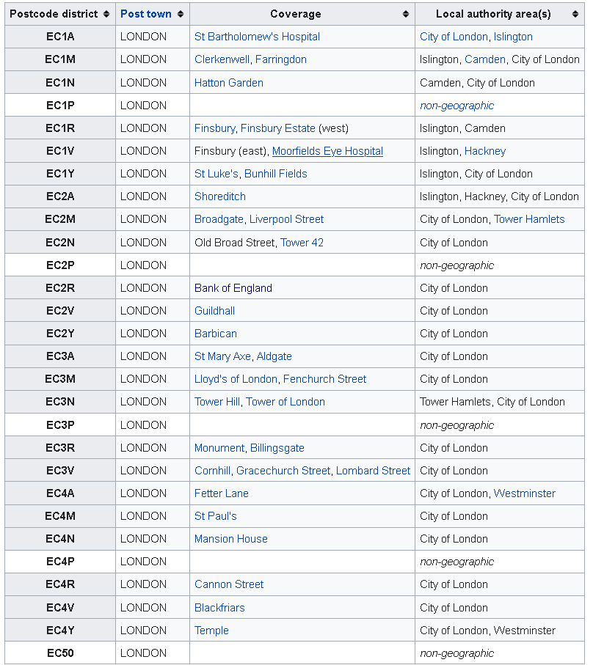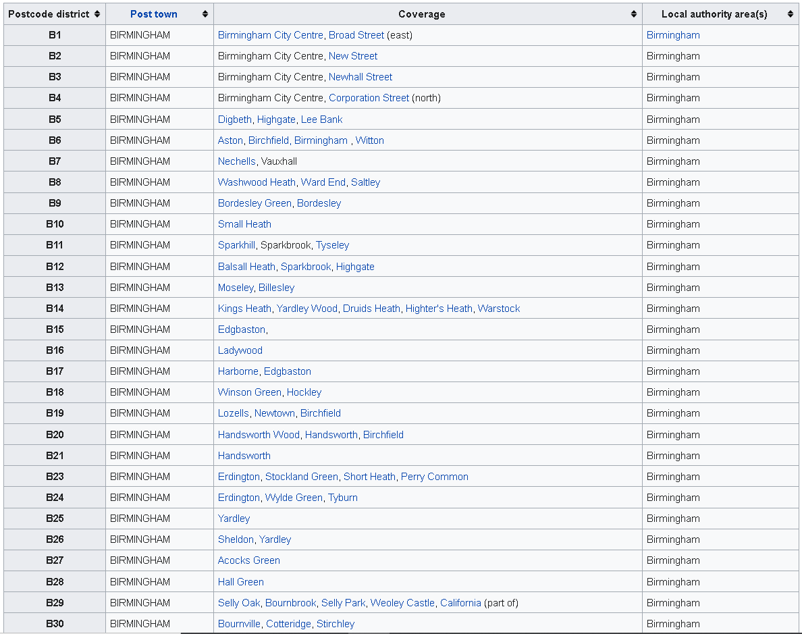Figures 1 and 4 show examples of postcode area data obtained. Appendix 1 shows the entire list of data used.

Figure 1- EC postcode area (Postcode Project, 2012)

Figure 2- B postcode area (Office of National Statistics, 2012)

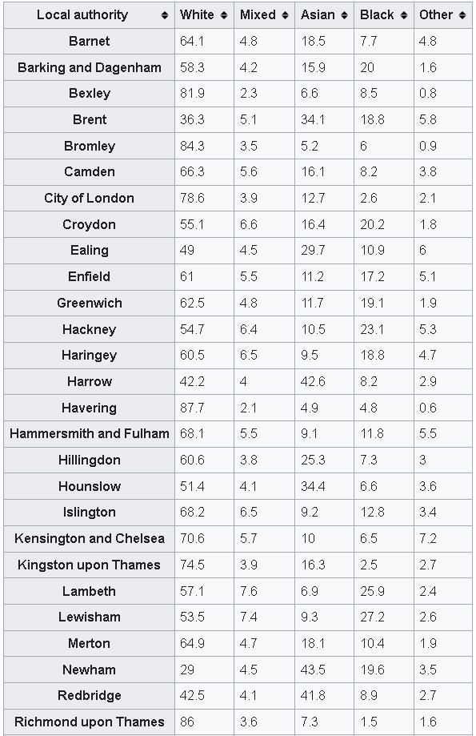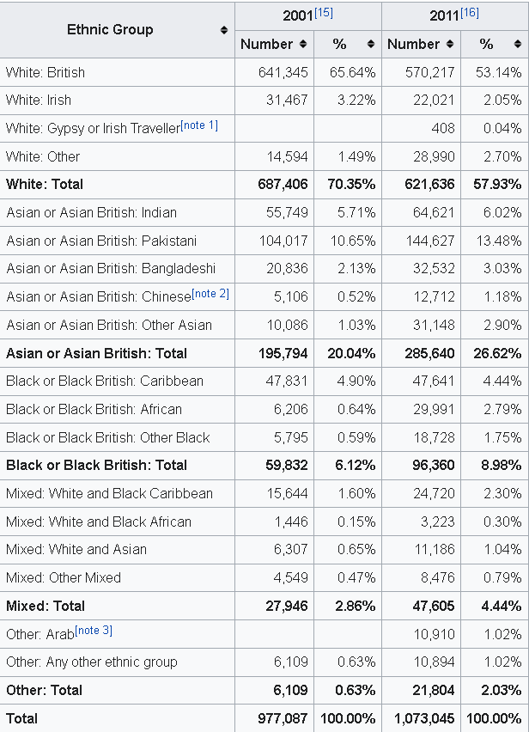Census 2011 provides the data for the diversity in population over Birmingham and East Central London shown in Figures 2 and 3. Appendix B shows the full list of population-based data obtained from Census 2011.

Figure 3- Ethnic Group Distribution over London Boroughs ( Census, 2011)

Figure 4- Ethnic Group Distribution in Birmingham (Census, 2011)

# 5.0 Methodology

Firstly, the postcode district areas for Birmingham City and East Central London run through a Location-based service (LBS) known as Geocoder API and Geolocator API from Google to convert the districts into longitude-latitude on the world map.

The Folium library in python uses the longitude-latitude values to plot the Neighborhoods on the location-specific map. The visualization helps with data analysis by interacting with raw data of numbers and words. It helps speed the process of data analysis as the human brain tends to process visual information in a brisk than any written communication presented. Furthermore, it draws the necessary relationships between the data of the two cities.

Following the data visualization of the postcode district for both cities, Foursquare API is used to obtain the top 100 venues in a radius of 500m of each Neighborhood. This report discards any venue that either falls outside the city boundary or could not be mapped in the same Neighborhood. This ensures the data representation from both cities is applied to the same data set points when venues are considered. The venues' category obtained merges with the Neighborhood to create a binary data frame of 0s and 1s. For example, if the Neighborhood has an 'Italian Restaurant,' it has a result of 1, and if the district does not have an Antique shop within the 500m radius and top 100 venues, then the output is 0. Subsequently, this data frame statistically examines the mean frequency of the venue’s categories in the district. As the number of 1s for 'Italian Restaurant' increases, the mean frequency of 'Italian Restaurant' in that Neighborhood increases.

The top 100 venues in the district's name and categories of the venues allow each Neighborhood's analyses to occur. This report uses the K-means algorithm to form a number of clusters in the postcode district areas with the venue's categories' mean frequency in each Neighborhood. From the top 100 venues, the top 10 types of venues merge with the Neighborhood to create a new data frame. This data frame is fed into the K-means algorithm to form the clusters. The different groups produced are compared to each other and labelled in the analyses. Finally, inside city cluster analyses occur, and the comparison is shifted to city-to-city examination.

# 6.0 DATA Wrangling

The DATA consisted of non-geographic postcode districts which must be removed from dataset to perform data analyses. Furthermore, in Birmingham postcode districts, other districts that are not present in the city were included. This was also removed to ensure that only the necessary data is analysed. Pandas library is used to create a data frame from the data set and Data cleaning is performed.

## 6.1 East Central London Data Cleaning

### 6.1.1 Code 1- Using Pandas Library creating data frame df_East_Central_London:

#Using Pandas Library to Read Csv file

df_East_Central_London= pd.read_csv('EC_Data.csv')

# Summary of Dataframe obtained

df_East_Central_London.head()

### 6.1.2 Output 1 – Summary of data frame for Postcode District of East Central London ( df_East_Central_London):

Table 1- Data frame for Postcode District of East Central London (df_East_Central_London)

|  | **Postcode district** | **Post town** | **Coverage** | **Local authority area(s)** |
| --- | --- | --- | --- | --- |
| **0** | EC1A | LONDON | St Bartholomew's Hospital | City of London, Islington |
| **1** | EC1M | LONDON | Clerkenwell, Farringdon | Islington, Camden, City of London |
| **2** | EC1N | LONDON | Hatton Garden | Camden, City of London |
| **3** | EC1P | LONDON | NaN | non-geographic |
| **4** | EC1R | LONDON | Finsbury, Finsbury Estate (west) | Islington, Camden |

### 6.1.3 – Code 2- Checking the shape of initial Data frame ( df_East_Central_London):

# Checking shape of the initial Dataframe

df_East_Central_London.shape

### 6.1.4- Output 2- Shape of the initial Data frame (df_East_Central_London):

(30, 4)

### 6.1.5- Code 3 -Data cleaning for initial Data frame (df_East_Central_London):

df_East_Central_London=df_East_Central_London[df_East_Central_London['Local authority area(s)']!='non-geographic']

### 6.1.6 – Code 4- Checking the shape of Updated data frame ( df_East_Central_London):

# Shape of the East Central London Data Obtained

df_East_Central_London.shape

### 6.1.7- Output 4- Shape of the updated Data frame (df_East_Central_London):

(25, 4)

## 6.2 Birmingham Data Cleaning

### 6.2.1 Code 1- Using Pandas Library creating Initial data frame df_Birmingham:

#Using Pandas Library to Read Csv file

df_Birmingham= pd.read_csv('Birmingham_Postcode_Data.csv')

# Summary of Dataframe obtained

df_Birmingham.head()

### 6.2.2 Output 1 – Summary of Data frame for Postcode district of Birmingham (df_Birmingham):

Table 2- Data frame for Postcode district of Birmingham (df_Birmingham)

|  | **Postcode district** | **Post town** | **Coverage** | **Local authority area(s)** |
| --- | --- | --- | --- | --- |
| **0** | B1 | BIRMINGHAM | Birmingham City Centre, Broad Street (east) | Birmingham |
| **1** | B2 | BIRMINGHAM | Birmingham City Centre, New Street | Birmingham |
| **2** | B3 | BIRMINGHAM | Birmingham City Centre, Newhall Street | Birmingham |
| **3** | B4 | BIRMINGHAM | Birmingham City Centre, Corporation Street (no... | Birmingham |
| **4** | B5 | BIRMINGHAM | Digbeth, Highgate, Lee Bank | Birmingham |

### 6.2.3 Code 2- Checking the shape of the initial Data frame of Birmingham ( df_Birmingham):

# Checking the shape of the initial DataFrame of Birmingham

df_Birmingham.shape

6.2.4 Output 2 – Shape of the Initial Data frame of Birmingham (df_Birmingham):

(78, 4)

### 6.2.5 Code 3 - Data cleaning for Birmingham data frame:

# Removing any non- geographic places

df_Birmingham=df_Birmingham[df_Birmingham['Local authority area(s)']!='non-geographic']

# Keeping only Birmingham in Local authority area(s)

df_Birmingham=df_Birmingham[df_Birmingham['Local authority area(s)']=='Birmingham']

# Keeping only Birmingham in Post Town

df_Birmingham=df_Birmingham[df_Birmingham['Post town']=='BIRMINGHAM']

### 6.2.6 Code 4 – Checking the shape of the Updated Data Frame (df_Birmingham):

# Checking the shape of the updated Birmingham Dataframe

df_Birmingham.shape

6.2.7 Output 4- Shape of the Updated Data Frame (df_Birmingham):

(37, 4)

# 7.0 GEOCODER API- Getting the Latitudes and Longitudes

**Geocoding** is the process of converting addresses (like a street address) into geographic coordinates (like latitude and longitude), which you can use to place markers on a map or position the map. So, the coverages name from the panda’s data frame is used as input to create the necessary latitudes and longitudes data. The result can be outputted in json or xml format. The output file is used with Pandas library to create a separate data frame and is merged with the initial Postcode district data frame- **df_Birmingham** and **df_East_Central_London**.

## 7.1 Converting Postcode into required longitude and Latitude

### 7.1.1- Creating the required function using Geocoder API:

# Function for converting London Location into Longitude and Latitude

def get_geocoder_ECL(postal_code):

    # initialize your variable to None

    lat_lng_coords = None

    while(lat_lng_coords is None):

        g = geocoder.google('{}, London, UK'.format(postal_code))

        lat_lng_coords = g.latlng

    latitude = lat_lng_coords[0]

    longitude = lat_lng_coords[1]

    return latitude,longitude

#Function for converting Birmingham Location into Longitude and Latitude

def get_geocoder_B(postal_code):

    # initialize your variable to None

    lat_lng_coords = None

    while(lat_lng_coords is None):

        g = geocoder.google('{}, Birmingham, UK'.format(postal_code))

        lat_lng_coords = g.latlng

    latitude = lat_lng_coords[0]

    longitude = lat_lng_coords[1]

    return latitude,longitude

### 7.1.2 For loop and using the created function get_geocoder:

## For loop for obtaining the Latitude and Longitude in ECL

 for i in range(0,len(df_East_Central_London)):

     df_East_Central_London['Latitude'][i],df_East_Central_London['Longitude'][i]=get_geocoder(df_East_Central_London.iloc[i]['Postcode district'])

## For loop for obtaining the Latitude and Longitude in Birmingham

 for i in range(0,len(df_Birmingham)):

     df_Birmingham['Latitude'][i],df_Birmingham['Longitude'][i]=get_geocoder(df_Birmingham.iloc[i]['Postcode district'])

## 7.2 - Merging the Two data frames together:

### 7.2.1 – Code 1 – Renaming columns and merging Data frame together for both cities (geo_df_ECL, geo_df_Birmingham):

# Renaming Necessary Columns for merging

geo_df_ECL.rename(columns={'Address':'Postcode district'},inplace=True)

geo_df_Birmingham.rename(columns={'Address':'Postcode district'},inplace=True)

# Merges geo_df and df_East_Central_London with reference to 'Postcode district'

geo_df_ECL_merged = pd.DataFrame.merge(geo_df_ECL, df_East_Central_London, on='Postcode district')

geo_df_Birmingham_merged = pd.DataFrame.merge(geo_df_Birmingham, df_Birmingham, on='Postcode district')

# Summary of the Merged Dataframe

geo_df_ECL_merged.head()

### 7.2.2- Output 1- Merged data frame for East Central London

Table 3- Merged data frame for East Central London ( geo_df_ECL_merged)

|  | **Postcode district** | **Latitude** | **Longitude** | **Easting** | **Northing** | **Post town** | **Coverage** | **Local authority area(s)** |
| --- | --- | --- | --- | --- | --- | --- | --- | --- |
| **0** | EC1A | 51.5203 | -0.104446 | 531612 | 181856 | LONDON | St Bartholomew's Hospital | City of London, Islington |
| **1** | EC1M | 51.5214 | -0.103593 | 531668 | 181980 | LONDON | Clerkenwell, Farringdon | Islington, Camden, City of London |
| **2** | EC1N | 51.5200 | -0.109137 | 531288 | 181815 | LONDON | Hatton Garden | Camden, City of London |
| **3** | EC1R | 51.5245 | -0.108978 | 531286 | 182315 | LONDON | Finsbury, Finsbury Estate (west) | Islington, Camden |
| **4** | EC1V | 51.5265 | -0.099303 | 531951 | 182555 | LONDON | Finsbury (east), Moorfields Eye Hospital | Islington, Hackney |

### 7.2.3- Code 2 – Checking the Summary of the Merged data frame of Birmingham( geo_df_Birmingham_merged):

# Summary of the Merged DataFrame

geo_df_Birmingham_merged.head()

### 7.2.4- Output 2- Merged data frame for Birmingham ( geo_df_Birmingham_merged)

Table 4- Merged data frame for Birmingham ( geo_df_Birmingham_merged)

|  | **Postcode district** | **Latitude** | **Longitude** | **Easting** | **Northing** | **Post town** | **Coverage** | **Local authority area(s)** |
| --- | --- | --- | --- | --- | --- | --- | --- | --- |
| **0** | B1 | 52.4796 | -1.90779 | 406360 | 286856 | BIRMINGHAM | Birmingham City Centre, Broad Street (east) | Birmingham |
| **1** | B2 | 52.4863 | -1.89732 | 407070 | 287603 | BIRMINGHAM | Birmingham City Centre, New Street | Birmingham |
| **2** | B3 | 52.4823 | -1.90289 | 406692 | 287157 | BIRMINGHAM | Birmingham City Centre, Newhall Street | Birmingham |
| **3** | B4 | 52.4838 | -1.89374 | 407313 | 287325 | BIRMINGHAM | Birmingham City Centre, Corporation Street (no... | Birmingham |
| **4** | B5 | 52.4722 | -1.89683 | 407105 | 286034 | BIRMINGHAM | Digbeth, Highgate, Lee Bank | Birmingham |

# 8.0 Geolocation API

The Geolocation API returns a location and accuracy radius based on information about cell towers and Wi-Fi nodes that the mobile client can detect. This is used to get the longitudes and latitudes for entire city location. The longitudes-latitudes values are then used by folium library to visualise the postcode district areas.

## 8.1 Using Geolocation API

### 8.1.1 Code 1- Getting the latitudes and longitudes of both cities from Geolocation API

# Example

# Address

address_ECL = "East Central London, UK"

address_Birmingham= "Birmingham, UK"

#Geolocator

geolocator = Nominatim(user_agent="London_explorer")

location_ECL = geolocator.geocode(address_ECL)

location_Birmingham= geolocator.geocode(address_Birmingham)

latitude_ECL = location_ECL.latitude

longitude_ECL = location_ECL.longitude

latitude_Birmingham = location_Birmingham.latitude

longitude_Birmingham= location_Birmingham.longitude

#Final print

print('The geograpical coordinate of East Central London city are {}, {}.'.format(latitude_ECL, longitude_ECL))

print('The geograpical coordinate of Birmingham city are {}, {}.'.format(latitude_Birmingham, longitude_Birmingham))

### 8.1.2 Output 1 - Latitude- Longitude values for East Central London city and Birmingham

The geograpical coordinate of East Central London city are 51.5051189, 0.0535883. The geograpical coordinate of Birmingham city are 52.4796992, -1.9026911.

# 9.0 Data visualising

Using Folium library in python, the longitudes and latitudes data values are plotted onto the world map.

## 9.1 Using Folium

### 9.1.1 Code 1- Creating the map of London and Birmingham using Folium Library ( Map_East_Central_London, Map_Birmingham):

# Creating a Map of London

Map_East_Central_London = folium.Map(location=[latitude_ECL, longitude_ECL], zoom_start=10)

Map_Birmingham = folium.Map( location =[latitude_Birmingham, longitude_Birmingham], zoom_start = 10)

### 9.1.2 Code 2 – Displaying the East Central London Map ( Map_East_Central_London):

# Display the London Map with zoom value of 10

Map_East_Central_London

### 9.1.3 Output 2 – Map of East Central London ( Map_East_Central_London):

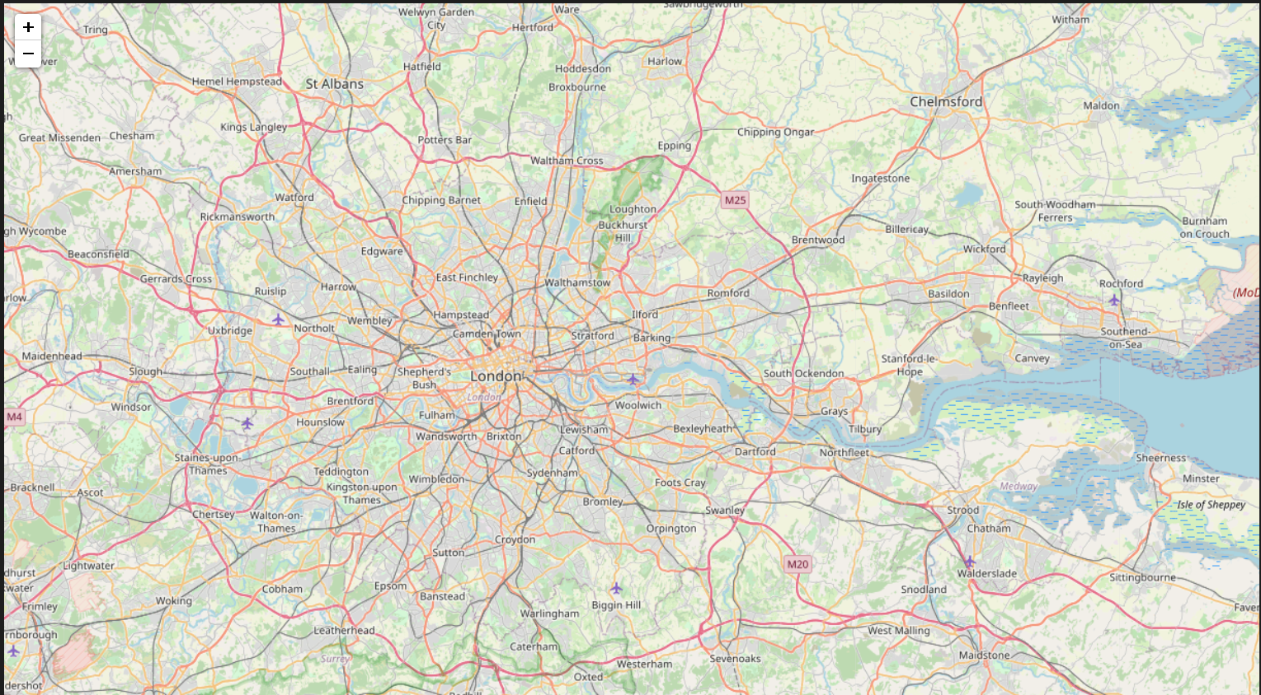

Figure 5 East Central London Map ( Map_East_Central_Map)

### 9.1.4 Code 3- Displaying the Birmingham City Map ( Map_Birmingham):

# Display Map of Birmingham with zoom of 10

Map_Birmingham

### 9.1.5 Output 3 – Map of Birmingham ( Map_ Birmingham):

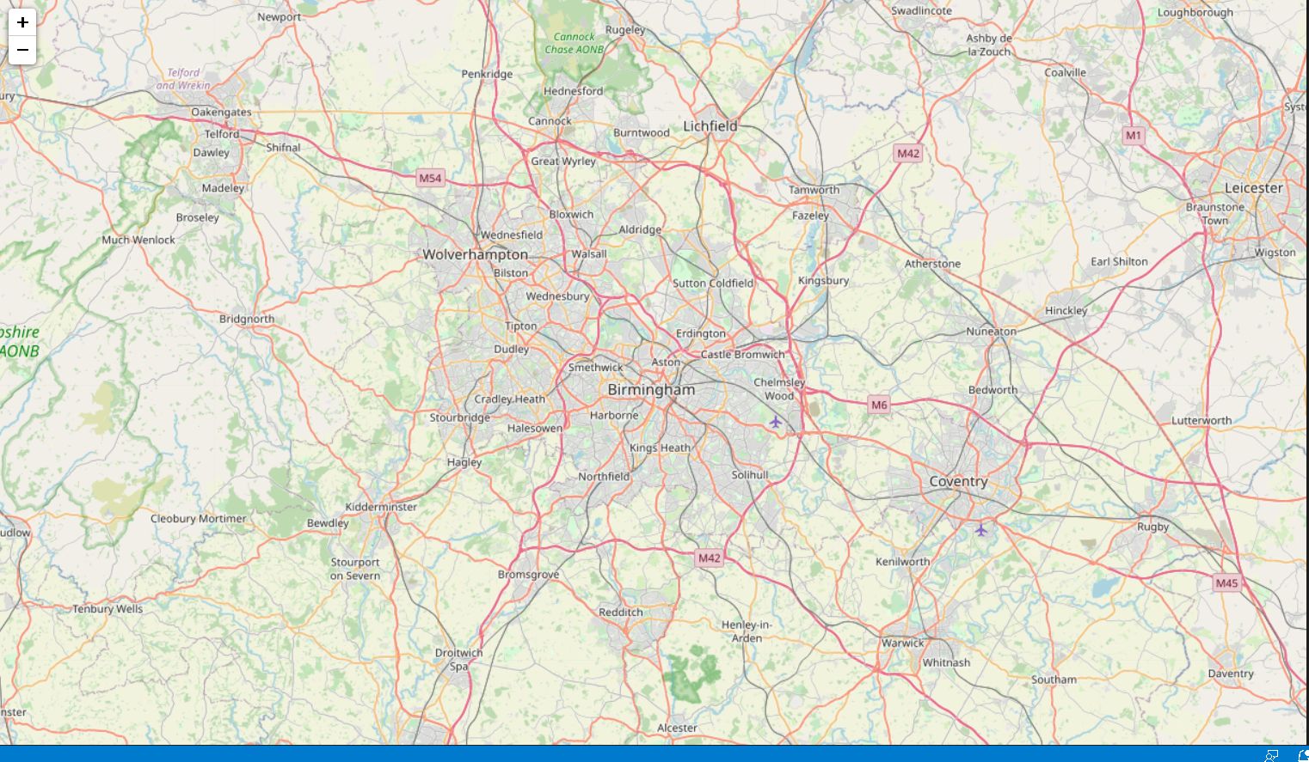

Figure 6- Birmingham Map ( Map_ Birmingham)

### 9.1.6 Code 4- For loop to extract all data from the merged data frame of East Central London ( geo_df_ECL_merged):

# For loop to extract necessary data from Dataframe

for lat_ECL, lng_ECL, borough_ECL, neighborhood_ECL in zip(

        geo_df_ECL_merged['Latitude'],

        geo_df_ECL_merged['Longitude'],

        geo_df_ECL_merged['Coverage'],

        geo_df_ECL_merged['Local authority area(s)']):

    label_ECL = '{}, {}'.format(neighborhood_ECL, borough_ECL)

    label_ECL = folium.Popup(label_ECL, parse_html=True)

    # Using Folium to mark Coverage/Neighbourhood by Blue Circles

    folium.CircleMarker(

        [lat_ECL, lng_ECL],

        radius=5,

        popup=label_ECL,

        color='blue',

        fill=True,

        fill_color='#3186cc',

        fill_opacity=0.7,

        parse_html=False).add_to(Map_East_Central_London)

# Displaying the Updated map

Map_East_Central_London

### 9.1.7 Output 4 – Circle Markers from the merged Data frame presented on the East Central London Map ( geo_df_ECL_merged, Map_East_Central_London):

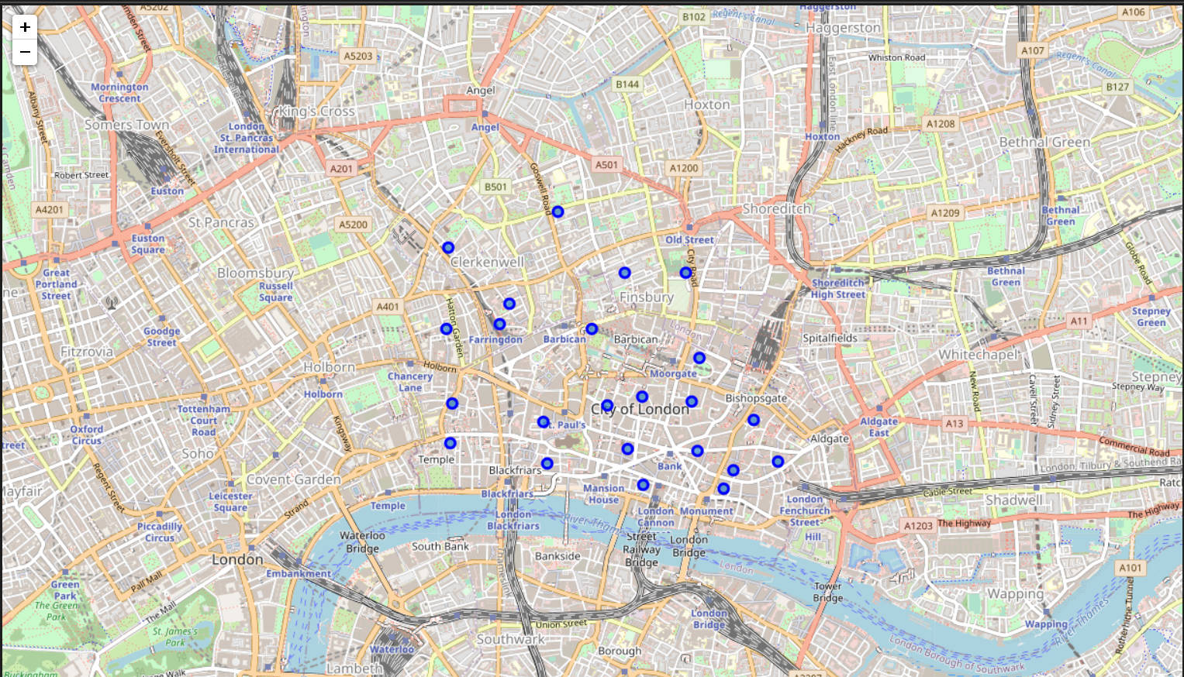

Figure 7- Visualisation of Postcode districts in East Central London ( geo_df_ECL_merged, Map_East_Central_London)

Figure 7 shows all the Coverages plotted on the map and all the plots are in East Central London. This helps visualise the Neighborhood areas that the report evaluates.

### 9.1.8 Code 5- For loop to extract all data from the merged data frame of Birmingham( geo_df_Birmingham_merged):

# For loop to extract necessary data from Dataframe

for lat, lng, borough, neighborhood in zip(

        geo_df_Birmingham_merged['Latitude'],

        geo_df_Birmingham_merged['Longitude'],

        geo_df_Birmingham_merged['Coverage'],

        geo_df_ECL_merged['Local authority area(s)']):

    label = '{}, {}'.format(neighborhood, borough)

    label = folium.Popup(label, parse_html=True)

    # Using Folium to mark Coverage/Neighbourhood by Blue Circles

    folium.CircleMarker(

        [lat, lng],

        radius=5,

        popup=label,

        color='red',

        fill=True,

        fill_color='#3186cc',

        fill_opacity=0.7,

        parse_html=False).add_to(Map_Birmingham)

# Displaying the Updated map

Map_Birmingham

### 9.1.9 Output 5 – Red Circle Markers from the merged Data frame presented on the Birmingham Map ( geo_df_Birmingham_merged, Map_Birmingham):

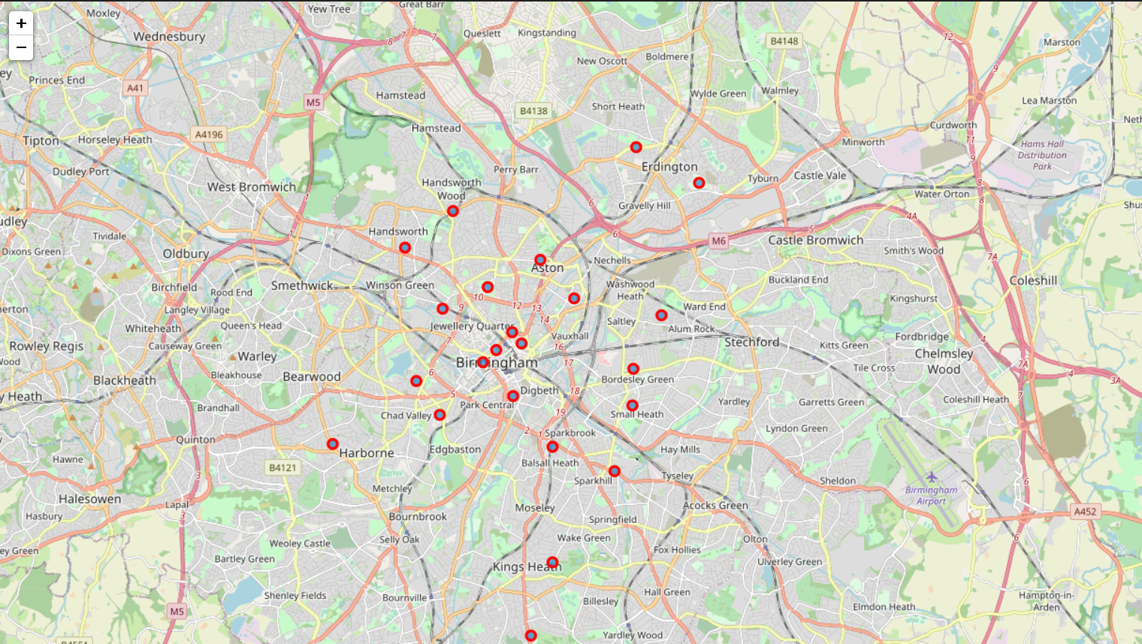

Figure 8- Visualisation of Postcode districts in Birmingham ( geo_df_Birmingham_merged, Map_Birmingham)

### 9.1.10 Both Clusters on Map of United Kingdom (Map_updated)

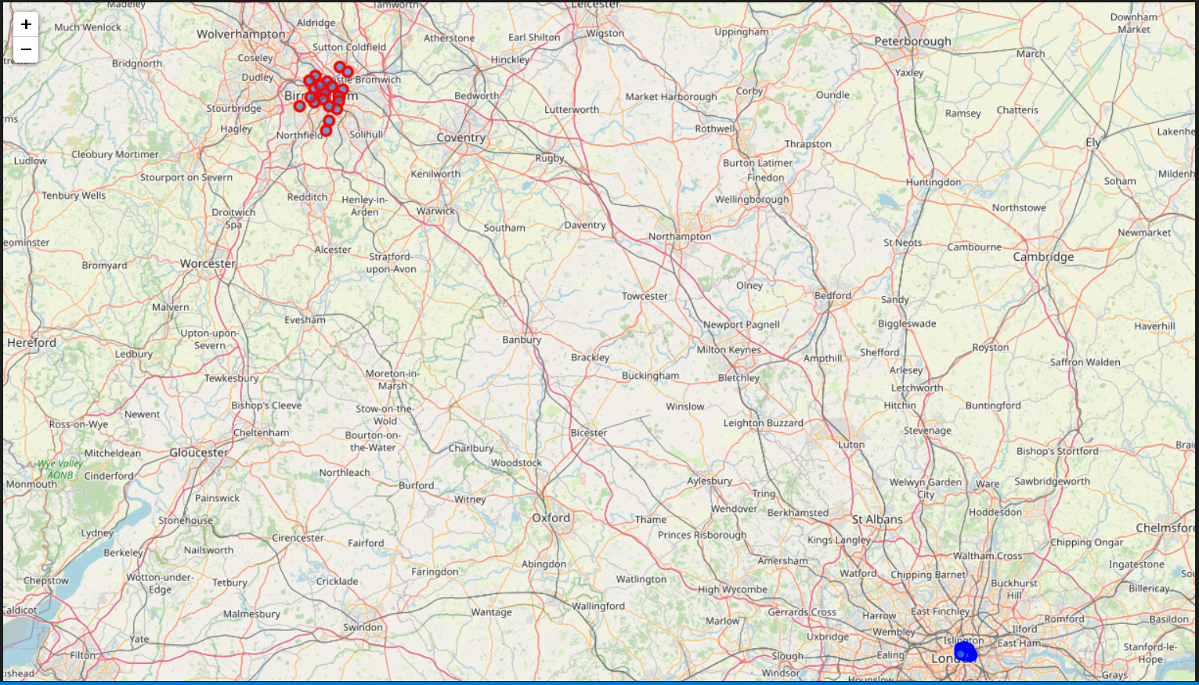

# 10.0 Foursquare API

The Foursquare API is used in this report to return venues at the selected postcode district areas. Top 100 venues are returned at the required district/Coverage in a radius of 500m .

## 10.1 Creating Function to retrieve venues data and create data frame:

### 10.1.1 Code 1- General Function getNearbyVenues:

def getNearbyVenues(names, latitudes, longitudes, radius=500):

    venues_list=[]

    for name, lat, lng in zip(names, latitudes, longitudes):

        # print(name)

        # create the API request URL

        url = 'https://api.foursquare.com/v2/venues/explore?&client_id={}&client_secret={}&v={}&ll={},{}&radius={}&limit={}'.format(

            CLIENT_ID,

            CLIENT_SECRET,

            VERSION,

            lat,

            lng,

            radius,

            LIMIT)

        # make the GET request

        results = requests.get(url).json()["response"]['groups'][0]['items']

        # return only relevant information for each nearby venue

        venues_list.append([(

            name,

            lat,

            lng,

            v['venue']['name'],

            v['venue']['location']['lat'],

            v['venue']['location']['lng'],

            v['venue']['categories'][0]['name']) for v in results])

    # Creating Dataframe from the Json file

    nearby_venues = pd.DataFrame([item for venue_list in venues_list for item in venue_list])

    nearby_venues.columns = ['Coverage',

                  'Coverage Latitude',

                  'Coverage Longitude',

                  'Venue',

                  'Venue Latitude',

                  'Venue Longitude',

                  'Venue Category']

    return(nearby_venues)

### 10.1.2 Code 2 – Using getNearbyVenues function for East Central London Postcode districts (East_Central_London_venues) :

# Creating dataframe East_Central_London_venues of Venues in East Central London

East_Central_London_venues = getNearbyVenues(names=geo_df_ECL_merged['Coverage'],

                                   latitudes=geo_df_ECL_merged['Latitude'],

                                   longitudes=geo_df_ECL_merged['Longitude']

                                  )

### 10.1.3 Code 3 – Using getNearbyVenues function for Birmingham Postcode districts ( Birmingham _venues)

# Creating dataframe Birmingham_venues of Venues in East Central London

Birmingham_venues= getNearbyVenues(names=geo_df_Birmingham_merged['Coverage'],

                                   latitudes=geo_df_Birmingham_merged['Latitude'],

                                   longitudes=geo_df_Birmingham_merged['Longitude']

                                  )

## 10.2 Checking the number of venues returned for each city

### 10.2.1 East Central London Venues

#### 10.2.1.1 Code 1- Counting the number of Venues returned ( East_Central_London_venues):

# Counting the number of Venues Returned

East_Central_London_venues.groupby('Coverage').count()

#### 10.2.1.2 Output 1- The Number of Venues per Postcode area district ( East_Central_London_venues):

Table 5- Number of Venues per Postcode Area District

|  | **Coverage Latitude** | **Coverage Longitude** | **Venue** | **Venue Latitude** | **Venue Longitude** | **Venue Category** |
| --- | --- | --- | --- | --- | --- | --- |
| **Coverage** |  |  |  |  |  |  |
| **Bank of England** | 100 | 100 | 100 | 100 | 100 | 100 |
| **Barbican** | 83 | 83 | 83 | 83 | 83 | 83 |
| **Blackfriars** | 68 | 68 | 68 | 68 | 68 | 68 |
| **Broadgate, Liverpool Street** | 51 | 51 | 51 | 51 | 51 | 51 |
| **Cannon Street** | 79 | 79 | 79 | 79 | 79 | 79 |
| **Clerkenwell, Farringdon** | 88 | 88 | 88 | 88 | 88 | 88 |
| **Cornhill, Gracechurch Street, Lombard Street** | 81 | 81 | 81 | 81 | 81 | 81 |
| **Fetter Lane** | 100 | 100 | 100 | 100 | 100 | 100 |
| **Finsbury (east), Moorfields Eye Hospital** | 62 | 62 | 62 | 62 | 62 | 62 |
| **Finsbury, Finsbury Estate (west)** | 100 | 100 | 100 | 100 | 100 | 100 |
| **Guildhall** | 100 | 100 | 100 | 100 | 100 | 100 |
| **Hatton Garden** | 78 | 78 | 78 | 78 | 78 | 78 |
| **Lloyd's of London, Fenchurch Street** | 82 | 82 | 82 | 82 | 82 | 82 |
| **Mansion House** | 100 | 100 | 100 | 100 | 100 | 100 |
| **Monument, Billingsgate** | 77 | 77 | 77 | 77 | 77 | 77 |
| **Old Broad Street, Tower 42** | 75 | 75 | 75 | 75 | 75 | 75 |
| **Shoreditch** | 90 | 90 | 90 | 90 | 90 | 90 |
| **St Bartholomew's Hospital** | 53 | 53 | 53 | 53 | 53 | 53 |
| **St Luke's, Bunhill Fields** | 89 | 89 | 89 | 89 | 89 | 89 |
| **St Mary Axe, Aldgate** | 100 | 100 | 100 | 100 | 100 | 100 |
| **St Paul's** | 100 | 100 | 100 | 100 | 100 | 100 |
| **Temple** | 87 | 87 | 87 | 87 | 87 | 87 |
| **Tower Hill, Tower of London** | 95 | 95 | 95 | 95 | 95 | 95 |

### 10.2.2 Birmingham Venues

#### 10.2.2.1 Code 1- Counting the number of venues in Birmingham (Birmingham_venues):

# Counting the number of Venues in Birmingham#

Birmingham_venues.groupby('Coverage').count()

#### 10.2.2.2 Output 1- Number of Venues in Birmingham ( Birmingham_venues):

|  | **Coverage Latitude** | **Coverage Longitude** | **Venue** | **Venue Latitude** | **Venue Longitude** | **Venue Category** |
| --- | --- | --- | --- | --- | --- | --- |
| **Coverage** |  |  |  |  |  |  |
| **Acocks Green** | 11 | 11 | 11 | 11 | 11 | 11 |
| **Aston, Birchfield, Birmingham , Witton** | 4 | 4 | 4 | 4 | 4 | 4 |
| **Balsall Heath, Sparkbrook, Highgate** | 7 | 7 | 7 | 7 | 7 | 7 |
| **Birmingham City Centre, Broad Street (east)** | 82 | 82 | 82 | 82 | 82 | 82 |
| **Birmingham City Centre, Corporation Street (north)** | 64 | 64 | 64 | 64 | 64 | 64 |
| **Birmingham City Centre, New Street** | 39 | 39 | 39 | 39 | 39 | 39 |
| **Birmingham City Centre, Newhall Street** | 66 | 66 | 66 | 66 | 66 | 66 |
| **Bordesley Green, Bordesley** | 5 | 5 | 5 | 5 | 5 | 5 |
| **Bournville, Cotteridge, Stirchley** | 4 | 4 | 4 | 4 | 4 | 4 |
| **Castle Vale** | 6 | 6 | 6 | 6 | 6 | 6 |
| **Digbeth, Highgate, Lee Bank** | 38 | 38 | 38 | 38 | 38 | 38 |
| **Edgbaston,** | 11 | 11 | 11 | 11 | 11 | 11 |
| **Erdington, Stockland Green, Short Heath, Perry Common** | 2 | 2 | 2 | 2 | 2 | 2 |
| **Erdington, Wylde Green, Tyburn** | 1 | 1 | 1 | 1 | 1 | 1 |
| **Hall Green** | 4 | 4 | 4 | 4 | 4 | 4 |
| **Handsworth** | 4 | 4 | 4 | 4 | 4 | 4 |
| **Handsworth Wood, Handsworth, Birchfield** | 1 | 1 | 1 | 1 | 1 | 1 |
| **Harborne, Edgbaston** | 5 | 5 | 5 | 5 | 5 | 5 |
| **Kings Heath, Yardley Wood, Druids Heath, Highter's Heath, Warstock** | 6 | 6 | 6 | 6 | 6 | 6 |
| **Kings Norton, West Heath** | 2 | 2 | 2 | 2 | 2 | 2 |
| **Kitts Green, Stechford** | 4 | 4 | 4 | 4 | 4 | 4 |
| **Ladywood** | 10 | 10 | 10 | 10 | 10 | 10 |
| **Lozells, Newtown, Birchfield** | 4 | 4 | 4 | 4 | 4 | 4 |
| **Moseley, Billesley** | 2 | 2 | 2 | 2 | 2 | 2 |
| **Nechells, Vauxhall** | 5 | 5 | 5 | 5 | 5 | 5 |
| **Northfield, Longbridge, West Heath** | 6 | 6 | 6 | 6 | 6 | 6 |
| **Perry Barr, Great Barr, Hamstead** | 5 | 5 | 5 | 5 | 5 | 5 |
| **Perry Barr, Kingstanding, Great Barr** | 7 | 7 | 7 | 7 | 7 | 7 |
| **Selly Oak, Bournbrook, Selly Park, Weoley Castle, California (part of)** | 5 | 5 | 5 | 5 | 5 | 5 |
| **Shard End, Buckland End** | 3 | 3 | 3 | 3 | 3 | 3 |
| **Sheldon, Yardley** | 3 | 3 | 3 | 3 | 3 | 3 |
| **Small Heath** | 9 | 9 | 9 | 9 | 9 | 9 |
| **Sparkhill, Sparkbrook, Tyseley** | 4 | 4 | 4 | 4 | 4 | 4 |
| **Winson Green, Hockley** | 2 | 2 | 2 | 2 | 2 | 2 |
| **Woodgate, Bartley Green, Quinton, California (part of)** | 1 | 1 | 1 | 1 | 1 | 1 |
| **Yardley** | 4 | 4 | 4 | 4 | 4 | 4 |

## 10.3 Checking the number of venues’ categories returned for each city

### 10.3.1 Code 1- Counting the total number of venues’ categories obtained for both cities( East_Central_London_venues, Birmingham_venues):

# Number of Unique Categories of Venues Obtained

print('There are {} uniques categories for East Central London Venues.'.format(len(East_Central_London_venues['Venue Category'].unique())))

print('There are {} uniques categories for Birmingham Venues. '.format(len(Birmingham_venues['Venue Category'].unique())))

### 10.3.2 Output 1 – Number of venues obtained for both cities( East_Central_London_venues, Birmingham_venues):

There are 158 uniques categories for East Central London Venues.

There are 134 uniques categories for Birmingham Venues.

## 11.0 Data Analysis

## 11.1 Analysing each Postcode area District separately:

### 11.1.1 East Central London- Binary Output of Venues’ categories

#### 11.1.1.1 Code 1 – Creating new Data frame for each Coverage/Neighborhood and the different venues’ categories in East Central London ( East_Central_London_venues, East_Central_London_onehot)

# one hot encoding

East_Central_London_onehot = pd.get_dummies(East_Central_London_venues[['Venue Category']], prefix="", prefix_sep="")

# add Coverage column back to dataframe

East_Central_London_onehot['Coverage'] = East_Central_London_venues['Coverage']

# move Coverage column to the first column

fixed_columns = [East_Central_London_onehot.columns[-1]] + list(East_Central_London_onehot.columns[:-1])

East_Central_London_onehot = East_Central_London_onehot[fixed_columns]

East_Central_London_onehot.head()

#### 11.1.1.2 Output 1- Summary of the new Data frame produced ( East_Central_London_onehot):

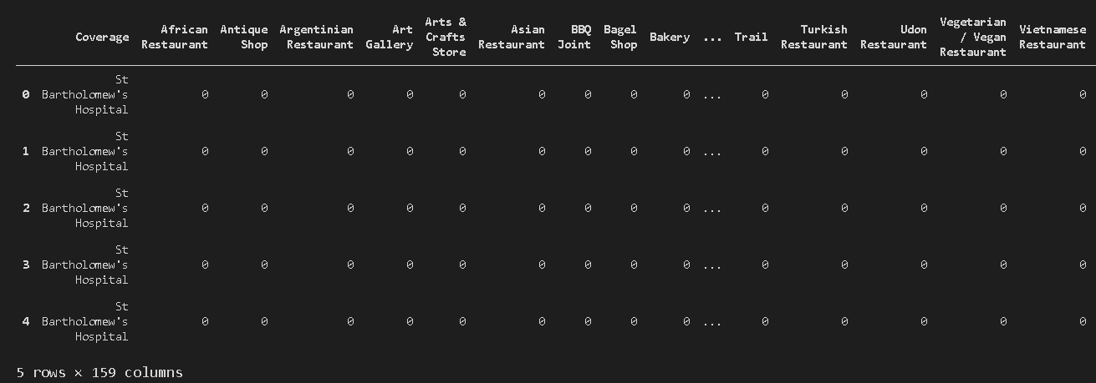

Figure 9- Summary of the new Data frame produced ( East_Central_London_onehot)

### 11.1.2 Birmingham – Binary Output of Venues’ categories

#### 11.1.1.1 Code 1 – Creating new Data frame for each Coverage/Neighborhood and the different venues’ categories in Birmingham (Birmingham_venues, Birmingham_onehot):

# one hot encoding

Birmingham_onehot = pd.get_dummies(Birmingham_venues[['Venue Category']], prefix="", prefix_sep="")

# add Coverage column back to dataframe

Birmingham_onehot['Coverage'] = Birmingham_venues['Coverage']

# move Coverage column to the first column

fixed_columns = [Birmingham_onehot.columns[-1]] + list(Birmingham_onehot.columns[:-1])

Birmingham_onehot = Birmingham_onehot[fixed_columns]

Birmingham_onehot.head()

#### 11.1.1.2 Output 1- Summary of the new data frame produced ( Birmingham_onehot):

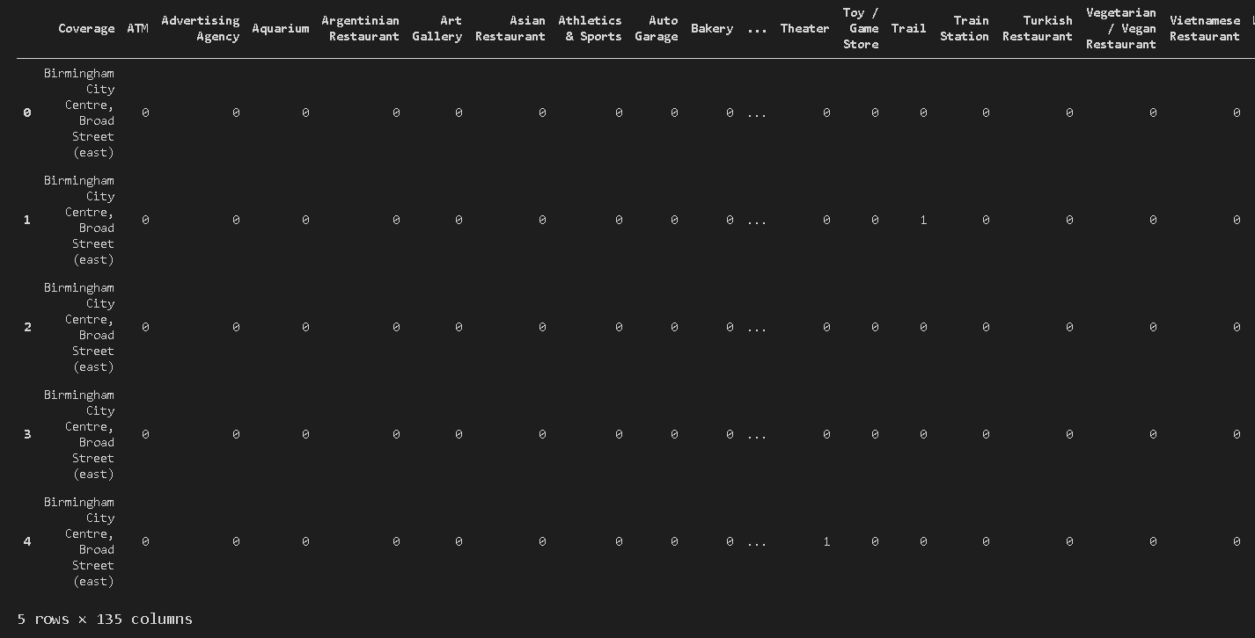

Figure 10- Summary of the new Data Frame produced ( Birmingham_onehot)

## 11.2 Grouping the Neighborhood with the mean frequency of venues’ categories:

### 11.2.1 East Central London

#### 11.2.1.1 Code 1 – Grouping by Neighborhood venues categories mean frequency ( East_Central_London_onehot, East_Central_London_grouped):

# Grouping by Coverage

East_Central_London_grouped = East_Central_London_onehot.groupby('Coverage').mean().reset_index()

East_Central_London_grouped.head()

#### 11.2.1.2 Output 1- Summary of the Grouping in East Central London ( East_Central_London_grouped):

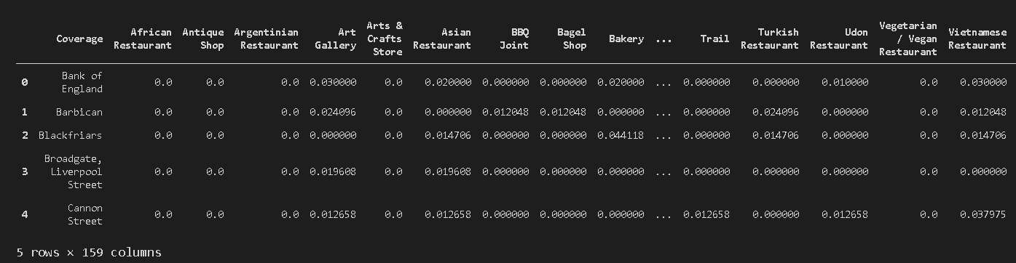

Figure 11- Summary of the Grouping in East Central London Venues ( East_Central_London_grouped)

### 11.2.2 Birmingham

#### 11.2.2.1 Code 1 – Grouping by Neighborhood venues categories mean frequency ( Birmingham_onehot, Birmingham_grouped):

# Grouping by Coverage

Birmingham_grouped = Birmingham_onehot.groupby('Coverage').mean().reset_index()

Birmingham_grouped.head()

11.2.2.2 Output 1 – Summary of the Grouping in Birmingham (Birmingham_grouped):

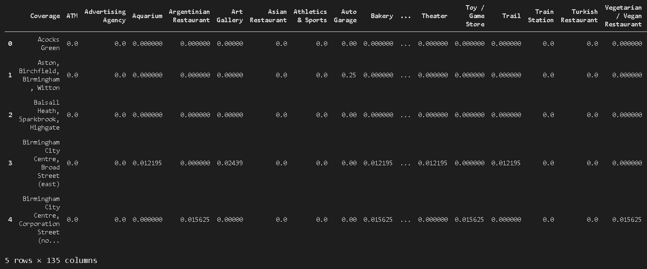

Figure 12- Summary of the Grouping in Birmingham ( Birmingham_grouped)

## 11.3 Getting the top 10 venues for each Neighborhood

### 11.3.1 East Central London

#### 11.3.1.1 Code 1 – Creating function and new data frame for each Neighborhood and top 10 venues categories name ( East_Central_London_grouped, Coverage_venues_ECL_sorted):

# Creating function to return the most common venues

def return_most_common_venues(row, num_top_venues):

    row_categories = row.iloc[1:]

    row_categories_sorted = row_categories.sort_values(ascending=False)

    return row_categories_sorted.index.values[0:num_top_venues]

#Setting the number of top Venues to be 10

num_top_venues = 10

indicators = ['st', 'nd', 'rd']

# create columns according to number of top venues

columns = ['Coverage']

for ind in np.arange(num_top_venues):

    try:

        columns.append('{}{} Most Common Venue'.format(ind+1, indicators[ind]))

    except:

        columns.append('{}th Most Common Venue'.format(ind+1))

# create a new dataframe

Coverage_venues_ECL_sorted = pd.DataFrame(columns=columns)

Coverage_venues_ECL_sorted['Coverage'] = East_Central_London_grouped['Coverage']

# Sorting the Obtained Dataframe with number of top venues

for ind in np.arange(East_Central_London_grouped.shape[0]):

    Coverage_venues_ECL_sorted.iloc[ind, 1:] = return_most_common_venues(East_Central_London_grouped.iloc[ind, :], num_top_venues)

Coverage_venues_ECL_sorted.head()

#### 11.3.1.2 Output 1 – Summary of the top 10 venues per Neighborhood in East Central London( Coverage_venues_ECL_sorted):

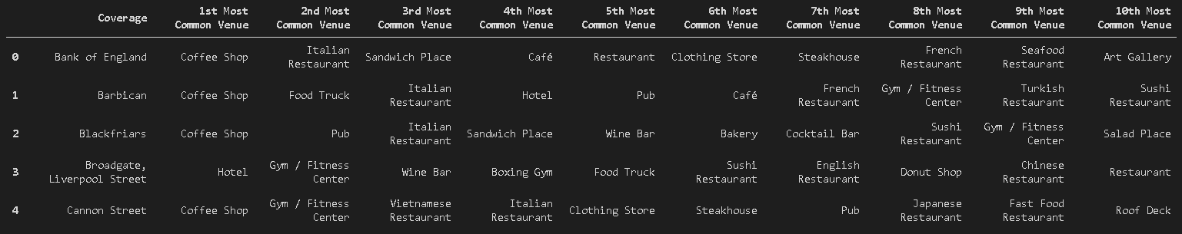

Figure 13- Summary of the top 10 venues per Neighborhood in East Central London( Coverage_venues_ECL_sorted)

### 11.3.2 Birmingham

#### 11.3.2.1 Code 1- Creating function and new data frame for each Neighborhood and top 10 venues categories name in Birmingham ( Birmingham_grouped, Coverage_venues_Birmingham_sorted):

# Creating function to return the most common venues

def return_most_common_venues(row, num_top_venues):

    row_categories = row.iloc[1:]

    row_categories_sorted = row_categories.sort_values(ascending=False)

    return row_categories_sorted.index.values[0:num_top_venues]

#Setting the number of top Venues to be 10

num_top_venues = 10

indicators = ['st', 'nd', 'rd']

# create columns according to number of top venues

columns = ['Coverage']

for ind in np.arange(num_top_venues):

    try:

        columns.append('{}{} Most Common Venue'.format(ind+1, indicators[ind]))

    except:

        columns.append('{}th Most Common Venue'.format(ind+1))

# create a new dataframe

Coverage_venues_Birmingham_sorted = pd.DataFrame(columns=columns)

Coverage_venues_Birmingham_sorted['Coverage'] = Birmingham_grouped['Coverage']

# Sorting the Obtained Dataframe with number of top venues

for ind in np.arange(Birmingham_grouped.shape[0]):

    Coverage_venues_Birmingham_sorted.iloc[ind, 1:] = return_most_common_venues(Birmingham_grouped.iloc[ind, :], num_top_venues)

Coverage_venues_Birmingham_sorted.head()

#### 11.3.2.2 Output 1 – Summary of top 10 venues categories for each Neighborhood in Birmingham ( Coverage_venues_Birmingham_sorted):

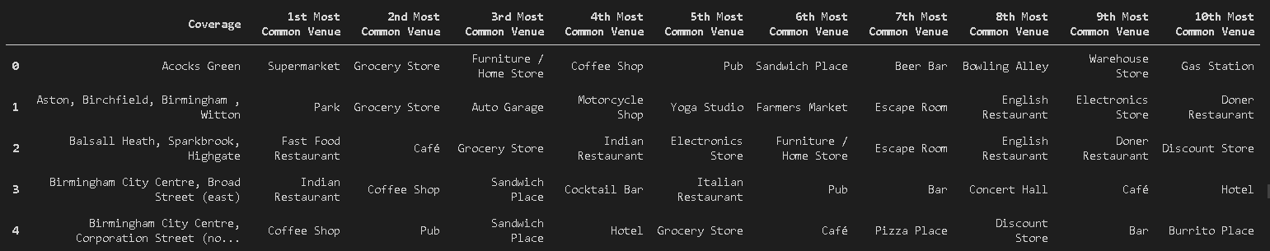

Figure 14- Summary of the top 10 venues' categories for each Neighborhood in Birmingham( Coverage_venues_Birmingham_sorted)

# 12.0 Machine Learning: K- Means Clustering

After having obtained the top 10 venues per Neighborhood, this report runs the data frame through K-means Clustering. This vector quantization method finds patterns in the neighbourhood venues’ categories and adjusts them into K number of clusters. Elbow method, Average silhouette method or Gap statistic Method can be used to find the optimum number for K. This problem is an example of unsupervised machine learning and therefore other machine learning algorithm such as SVM, Logistic Regression and Decision Trees are not a viable option. They solve supervised machine learning problems which requires having a dataset labelled and learning from it.

## 12.1 East Central London- K- means Clustering

### 12.1.1 Fitting the data frame with a random initialization ( East_Central_London_grouped, kmeans_ECL):

    # set number of clusters

    kclusters= 5

    East_Central_London_grouped_clustering = East_Central_London_grouped.drop('Coverage', 1)

    # run k-means clustering

    kmeans_ECL = KMeans(n_clusters=kclusters, random_state=0).fit(East_Central_London_grouped_clustering )

    # check cluster labels generated for each row in the dataframe

    kmeans_ECL.labels_[0:10]

### 12.1.2 Output of K-means Clustering fit for East Central London (kmeans_ECL):

array([1, 0, 2, 3, 1, 4, 1, 2, 0, 4])

### 12.1.3 Elbow Method for East Central London

#### 12.1.3.1 Code 1 – Elbow Method for analysing the k value ( East_Central_London_grouped_clustering, km):

Sum_of_squared_distances = []

K = range(1,15)

for k in K:

    km = KMeans(n_clusters=k)

    km = km.fit(East_Central_London_grouped_clustering)

    Sum_of_squared_distances.append(km.inertia_)

import matplotlib.pyplot as plt

plt.plot(K, Sum_of_squared_distances, 'bx-')

plt.xlabel('k')

plt.ylabel('Sum_of_squared_distances')

plt.title('Elbow Method For Optimal k')

plt.show()

#### 12.1.3.2 Output 1- Elbow Method for Optimum K value for East Central London Data(km):

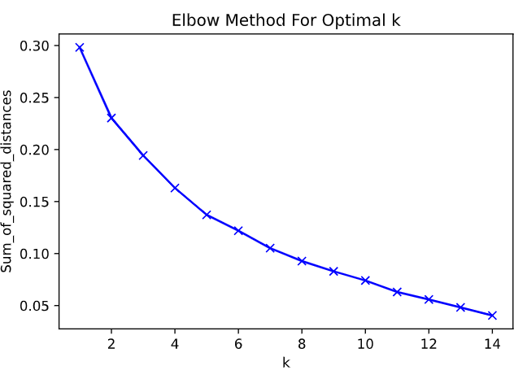

Figure 15- Elbow Method for Optimal K

Figure 15 does not have enough evidence to conclude the optimal K value as it has no Elbow. Further analysis must be carried out to obtain evidence.

### 12.1.4 Average Silhouette method for East Central London

#### 12.1.4.1 Code 1- For loop for running the Silhouette score metrics for K- means Cluster for East Central London data frame ( East_London_grouped_clustering, kmeans_ECL, Silhouette_score):

from sklearn.metrics import silhouette_score

Silhouette_score=[]

kclusters= range(2,15)

for k in kclusters:

    #run k-means clustering

    kmeans_ECL = KMeans(n_clusters=kclusters, random_state=0).fit(East_Central_London_grouped_clustering )

    #Obtains silhouette score for particular k value

    score = silhouette_score(East_Central_London_grouped_clustering, kmeans_ECL.labels_, metric = 'euclidean')

    #Adds the score value to the Silhouette_score list

    Silhouette_score.append(score)

# Plotting the data

Max= max(Silhouette_score)

plt.plot(k, Silhouette_score, 'bx-')

plt.xlabel('k')

plt.ylabel('Silhouette_score')

plt.title('Average Silhouette Method For Optimal k')

plt.plot(x, Silhouette_score, linestyle='--') # dashed

plt.legend('')

plt.show()

#### 12.1.4.2 Output 1- Average Silhouette Method for Optimum K value for East Central London:

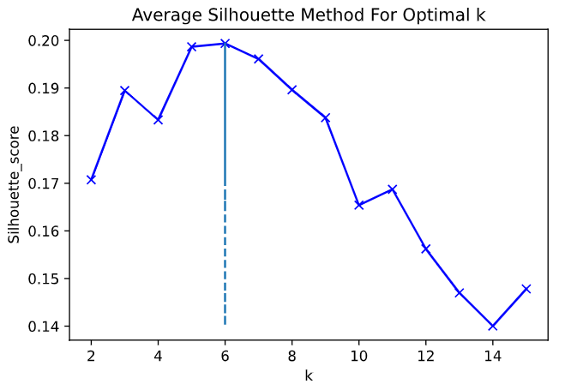

Figure 16- Average Silhouette Method for Optimum K value( Silhouette_score, k)

Figure 16 shows the maximum silhouette score is at 6 k clusters. This is the value that will be used for analysing the Neighbourhoods in East Central London.

### 12.1.5 Adding Cluster Labels to the New data frame and Merging two Data frames together(Coverage_venues_ECL_sorted, East_Central_London_merged)

#### 12.1.5.1 Code 1 – Adding Cluster Labels and Merging the data frames together ( Coverage_venues_ECL_sorted, East_Central_London_merged):

# add clustering labels

Coverage_venues_ECL_sorted.insert(0, 'Cluster Labels', kmeans_ECL.labels_)

East_Central_London_merged = geo_df_ECL_merged

# Merge East_Central_London_merged with geo_merged to add latitude/longitude for each neighborhood

East_Central_London_merged =geo_df_ECL_merged.join(Coverage_venues_ECL_sorted.set_index('Coverage'), on='Coverage')

# Summary of the Cluster Obtained

East_Central_London_merged.head()

#### 12.1.5.2 Output 1- Summary of the new merged data frame with the cluster labels ( East_Central_London_merged):

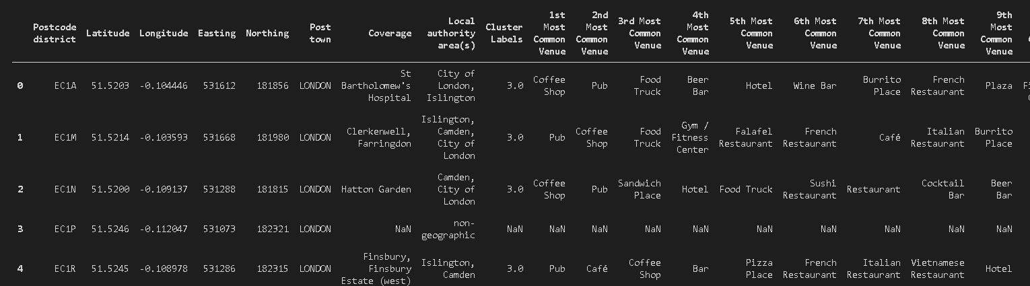

Figure 17- Summary of the new merged data frame with the new cluster labels (East_Central_London_merged)

### 12.1.6 Visualising Clusters on Map ( map_clusters_ECL):

#### 12.1.6.1 Code 1 – Creating Map and setting different colour scheme for different Clusters ( East_Central_London_merged, map_clusters_ECL):

# create map

map_clusters_ECL = folium.Map(location=[latitude_ECL, longitude_ECL], zoom_start=11)

# set color scheme for the clusters

x = np.arange(kclusters)

ys = [i + x + (i*x)**2 for i in range(kclusters)]

colors_array = cm.rainbow(np.linspace(0, 1, len(ys)))

rainbow = [colors.rgb2hex(i) for i in colors_array]

# add markers to the map

markers_colors = []

for lat, lon, poi, cluster in zip(

        East_Central_London_merged['Latitude'],

        East_Central_London_merged['Longitude'],

        East_Central_London_merged['Coverage'],

        East_Central_London_merged['Cluster Labels']):

    label = folium.Popup(str(poi) + ' Cluster ' + str(cluster), parse_html=True)

    folium.CircleMarker(

        [lat, lon],

        radius=5,

        popup=label,

        color=rainbow[cluster-1],

        fill=True,

        fill_color=rainbow[cluster-1],

        fill_opacity=0.7).add_to(map_clusters_ECL)

map_clusters_ECL

#### 12.1.6.2 Output 1 – Map of East Central London Cluster of venues’ categories ( map_clusters_ECL):

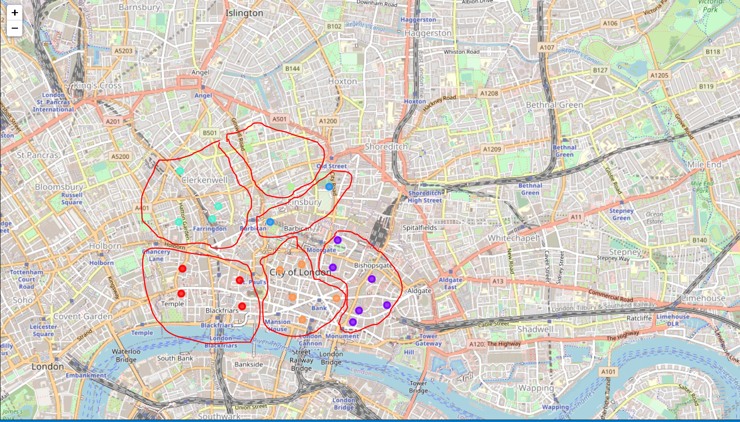

Figure 18- Map of East Central London Clusters of venues categories

### 12.1.7 Analysing different Clusters of East Central London and labelling them.

### 12.1.7.1 Cluster 1- Restaurants Venue- Variety of Foods

#### 12.1.7.1.1 Code 1- Getting Cluster 1 Data frame ( East_Central_London_merged)

# Cluster 1

East_Central_London_merged.loc[East_Central_London_merged['Cluster Labels'] == 0, East_Central_London_merged.columns[[1] + list(range(5, East_Central_London_merged.shape[1]))]]

#### 12.1.7.1.2 Output 1- Cluster 1 Data frame ( East_Central_London_merged_Cluster_1)

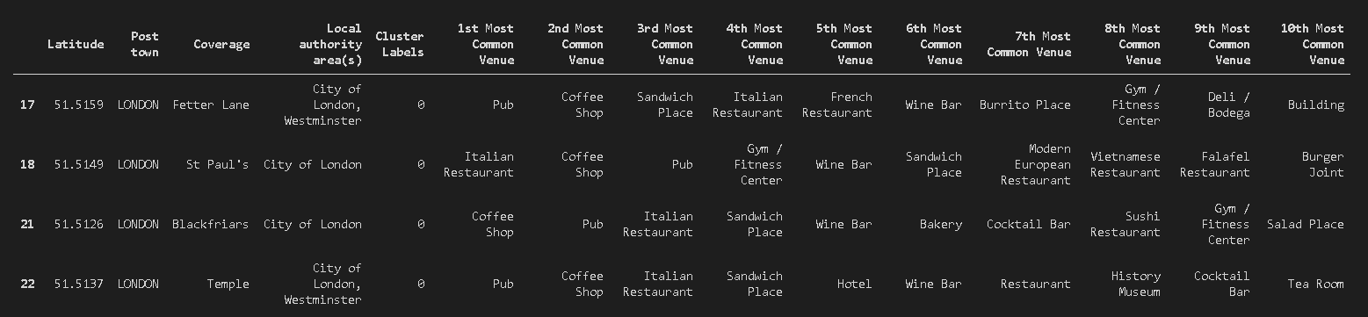

Figure 19- Cluster 1 Data frame of East Central London( East_Central_London_merged_Cluster_1)

Figure 19 shows that Cluster 1 can be labelled as a Restaurant Venue Area where all the different types of food is available for the residents to eat. Furthermore, Cluster 1 has Gym available in 3 out of 4 neighbourhoods.

### 12.1.7.2 Cluster 2- Hotels and Tourists Necessities

#### 12.1.7.2.1 Code 1- Getting Cluster 2 Data frame ( East_Central_London_merged_Cluster_2):

# Cluster 2

East_Central_London_merged.loc[East_Central_London_merged['Cluster Labels'] == 1, East_Central_London_merged.columns[[1] + list(range(5, East_Central_London_merged.shape[1]))]]

#### 12.1.7.2.2 Output 1- Cluster 2 Data frame ( East_Central_London_merged_Cluster_2):

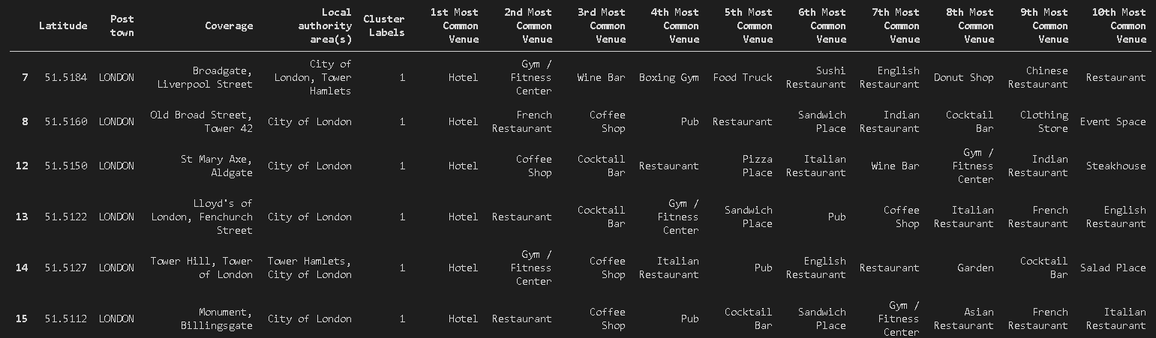

Figure 20- Cluster 2 Data frame of East Central London ( East_Central_London_merged_Cluster_2)

Figure 20 shows that the most common venue in all the neighbourhoods present in this cluster is Hotel. This Cluster can be labelled as Tourists necessities area where all the necessary venues are available to tourists. Different food restaurants, Garden, pubs, and event space is available at a reasonable distance to each neighbourhood.

### 12.1.7.3 Cluster 3- Common Residential Venues

#### 12.1.7.3.1 Code 1- Getting Cluster 3 Data frame ( East_Central_London_merged_Cluster_3):

# Cluster 3

East_Central_London_merged.loc[East_Central_London_merged['Cluster Labels'] == 2, East_Central_London_merged.columns[[1] + list(range(5, East_Central_London_merged.shape[1]))]]

#### 12.1.7.3.2 Output 1- Cluster 3 Data frame ( East_Central_London_merged_Cluster_3):

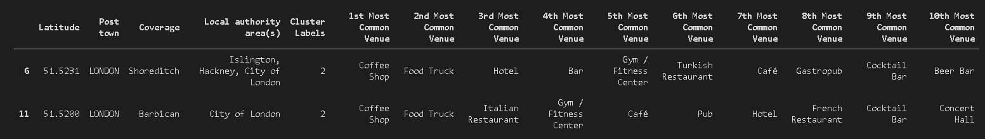

Figure 21- Cluster 3 Data frame of East Central London ( East_Central_London_merged_Cluster_3)

### 12.1.7.4 Cluster 4- Common Residential Venues

#### 12.1.7.4.1 Code 1- Getting Cluster 4 Data frame ( East_Central_London_merged_Cluster_4):

# Cluster 4

East_Central_London_merged.loc[East_Central_London_merged['Cluster Labels'] == 3, East_Central_London_merged.columns[[1] + list(range(5, East_Central_London_merged.shape[1]))]]

#### 12.1.7.4.2 Output 1- Cluster 4 Data frame ( East_Central_London_merged_Cluster_4):

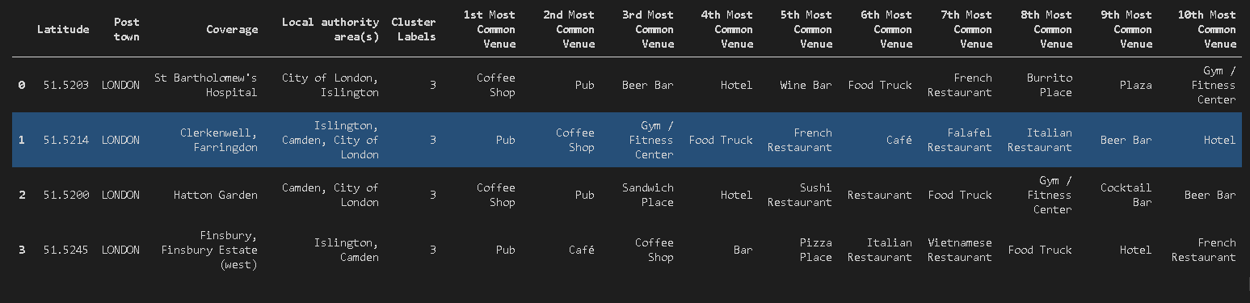

Figure 22- Cluster 4 Data Frame of East Central London( East_Central_London_merged_Cluster_4)

### 12.1.7.5 Cluster 5- Fast food Venues

#### 12.1.7.5.1 Code 1- Getting Cluster 5 Data frame ( East_Central_London_merged_Cluster_5):

# Cluster 5

East_Central_London_merged.loc[East_Central_London_merged['Cluster Labels'] == 4, East_Central_London_merged.columns[[1] + list(range(5, East_Central_London_merged.shape[1]))]]

#### 12.1.7.5.2 Output 1- Cluster 5 Data frame ( East_Central_London_merged_Cluster_5):

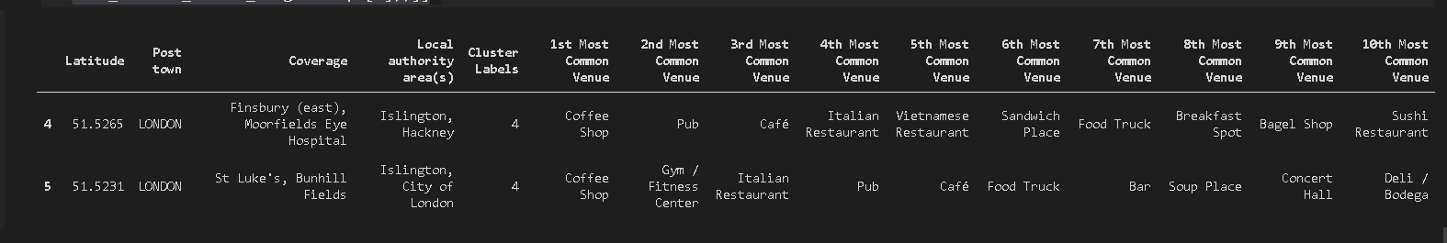

Figure 23- Cluster 5 Data Frame of East Central London (East_Central_London_merged_Cluster_5)

### 12.1.7.6 Cluster 6- Tourist Attraction

#### 12.1.7.6.1 Code 1- Getting Cluster 6 Data frame ( East_Central_London_merged_Cluster_6):

# Cluster 6

East_Central_London_merged.loc[East_Central_London_merged['Cluster Labels'] == 5, East_Central_London_merged.columns[[1] + list(range(5, East_Central_London_merged.shape[1]))]]

#### 12.1.7.6.2 Output 1- Cluster 6 Data frame ( East_Central_London_merged_Cluster_6):

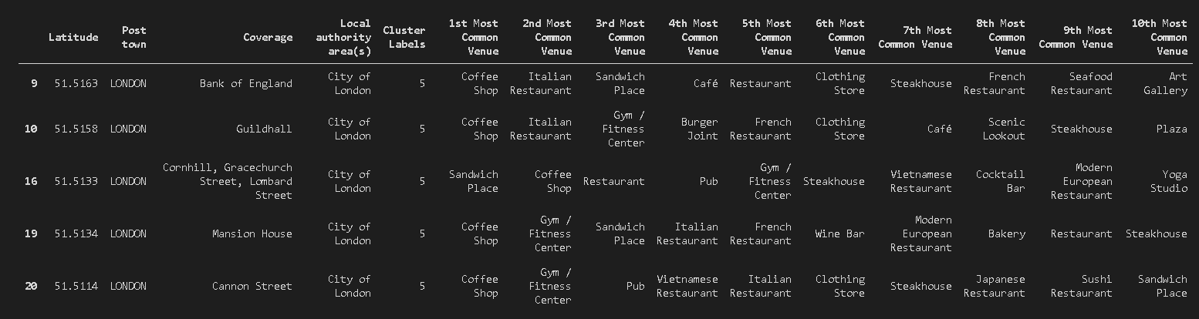

Figure 24- Cluster 6 Data Frame of East Central London ( East_Central_London_merged_Cluster_6)

## 12.2 Birmingham – K-means Clustering

12.2.1 Fitting the data frame with random initialization ( Birmingham_grouped_clustering)

# set number of clusters

kclusters_Birmingham = 8

Birmingham_grouped_clustering = Birmingham_grouped.drop('Coverage', 1)

# run k-means clustering

kmeans_Birmingham = KMeans(n_clusters=kclusters_Birmingham, random_state=0).fit(Birmingham_grouped_clustering)

# check cluster labels generated for each row in the dataframe

kmeans_Birmingham.labels_[0:36]

### 12.2.2 Output of K means Clustering Fit on Birmingham data ( kmeans_Birmingham):

array([2, 0, 7, 2, 2, 2, 2, 2, 0, 5, 5, 2, 3, 1, 2, 7, 3, 2, 5, 7, 2, 7,

5, 5, 7, 2, 5, 5, 2, 5, 2, 7, 5, 6, 4, 2])

### 12.2.3 Elbow Method for Birmingham

#### 12.2.3.1 Code 1 – Elbow Method Analysis analysing the k value ( Birmingham_grouped_clustering, km)

Sum_of_squared_distances = []

K = range(1,15)

for k in K:

    km_Birmingham = KMeans(n_clusters=k)

    km_Birmingham = km_Birmingham.fit(Birmingham_grouped_clustering)

    Sum_of_squared_distances.append(km_Birmingham.inertia_)

import matplotlib.pyplot as plt

plt.plot(K, Sum_of_squared_distances, 'bx-')

plt.xlabel('k')

plt.ylabel('Sum_of_squared_distances')

plt.title('Elbow Method For Optimal k')

plt.show()

#### 12.2.3.2 Output 1- Elbow Method for Optimising K value

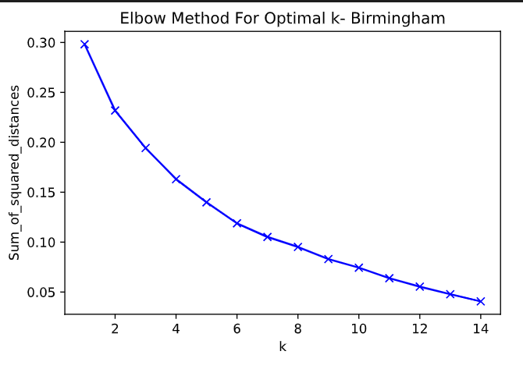

Figure 25- Elbow Method for Optimising K value for Birmingham Data frame ( km_Birmingham)

Figure 25 does not have enough evidence as the elbow is not clear. Silhouette method is used to gain further evidence.

### 12.2.4 Average Silhouette method for Birmingham

#### 12.2.4.1 Code 1- For loop for running the Silhouette score metrics for K- means Cluster for Birmingham data frame ( Birmingham_grouped_clustering, kmeans_Birmingham, Silhouette_score_Birmingham):

from sklearn.metrics import silhouette_score

Silhouette_score_Birmingham=[]

kclusters= range(2,15)

for k in kclusters:

    #run k-means clustering

    kmeans_Birmingham = KMeans(n_clusters=kclusters, random_state=0).fit(Birmingham_grouped_clustering )

    #Obtains silhouette score for particular k value

    score = silhouette_score(Birmingham_grouped_clustering, kmeans_Birmingham.labels_, metric = 'euclidean')

    #Adds the score value to the Silhouette_score list

    Silhouette_score_Birmingham.append(score)

# Plotting the data

Max= max(Silhouette_score_Birmingham)

plt.plot(k, Silhouette_score_Birmingham, 'bx-')

plt.xlabel('k')

plt.ylabel('Silhouette_score')

plt.title('Average Silhouette Method For Optimal k')

plt.show()

#### 12.2.4.2 Output 1- Average Silhouette Method for Optimal K for Birmingham ( Silhouette_score_Birmingham, k)

Figure 26- Average Silhouette Method for Optimal K value in Birmingham

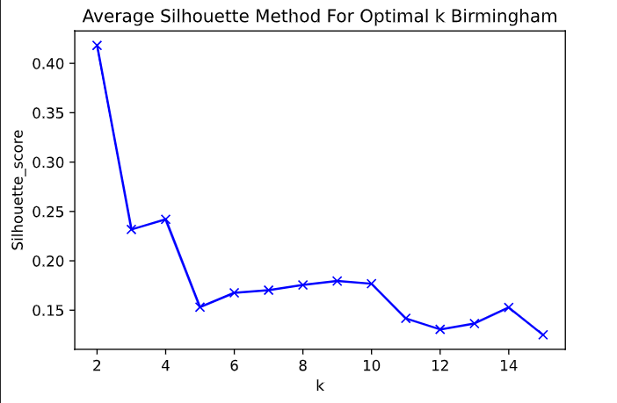

### 12.2.5 Adding Cluster Labels to the New data frame and Merging two Data frames together(Coverage_venues_Birmingham_sorted, Birmingham_merged)

#### 12.2.5.1 Code 1-Adding Cluster Labels and Merging the data frames together (Coverage_venues_Birmingham_sorted, Birmingham_merged):

#Removing clustering labels if already present

#Coverage_venues_Birmingham_sorted= Coverage_venues_Birmingham_sorted.drop(['Cluster Labels'], axis = 1)

# add clustering labels

Coverage_venues_Birmingham_sorted.insert(0, 'Cluster Labels', kmeans_Birmingham.labels_)

Birmingham_merged = geo_df_Birmingham_merged

# Merge East_Central_London_merged with geo_merged to add latitude/longitude for each neighborhood

Birmingham_merged =geo_df_Birmingham_merged.join(Coverage_venues_Birmingham_sorted.set_index('Coverage'), on='Coverage')

# Summary of the Cluster Obtained

Birmingham_merged.head()

#### 12.1.5.2 Output 1- Summary of the new merged data frame with the cluster labels ( Birmingham_merged):

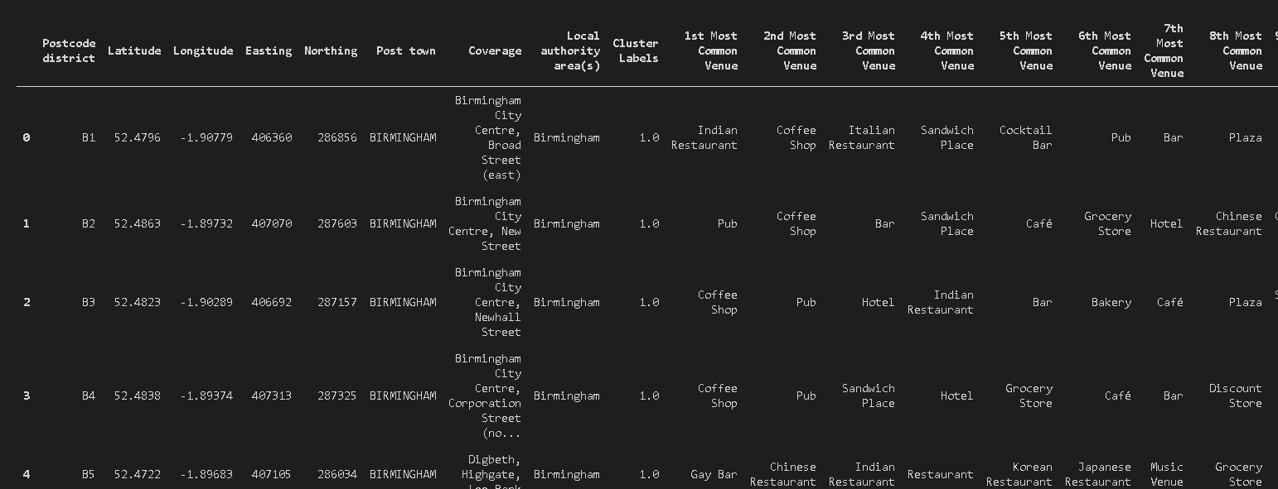

Figure 27- Summary of the new Merged Data frame with cluster Labels of Birmingham ( Birmingham_merged)

### 12.2.6 Visualising Clusters on Map ( map_clusters_Birmingham)

#### 12.2.6.1 Cleaning the data to fit on the map

##### 12.2.6.1.1 Example of NaN value in Birmingham data ( Birmingham_Merged)



Figure 28- NaN values obtained from Data Analysis of Birmingham Data frame ( Birmingham_merged)

##### 12.2.6.1.2 Code 1- Removing NaN values and turning Cluster Labels into Integers ( Birmingham_merged):

## Dropping any NaN values

Birmingham_merged.dropna(subset= ['1st Most Common Venue'], inplace= True)

# Turning Cluster Labels as integer

Birmingham_merged['Cluster Labels'] = Birmingham_merged['Cluster Labels'].astype(int)

##### 12.2.6.1.3 Output 1- Removed NaN values and Cluster Labels turned into integer from Birmingham Data frame ( Birmingham_merged):



Figure 29- Cluster Labels turned into integers and Removed NaN value rows in Birmingham Data frame

#### 12.2.6.2 Code 1- Creating Map and setting different colour scheme for different Clusters (Birmingham_merged, map_clusters_Birmingham):

# create map

map_clusters_Birmingham = folium.Map(location=[latitude_Birmingham, longitude_Birmingham], zoom_start=11)

# set color scheme for the clusters

x = np.arange(kclusters_Birmingham)

ys = [i + x + (i*x)**2 for i in range(kclusters_Birmingham)]

colors_array = cm.rainbow(np.linspace(0, 1, len(ys)))

rainbow = [colors.rgb2hex(i) for i in colors_array]

# add markers to the map

markers_colors = []

for lat, lon, poi, cluster in zip(

        Birmingham_merged['Latitude'],

        Birmingham_merged['Longitude'],

        Birmingham_merged['Coverage'],

        Birmingham_merged['Cluster Labels']):

    label = folium.Popup(str(poi) + ' Cluster ' + str(cluster), parse_html=True)

    folium.CircleMarker(

        [lat, lon],

        radius=5,

        popup=label,

        color=rainbow[cluster-1],

        fill=True,

        fill_color=rainbow[cluster-1],

        fill_opacity=0.7).add_to(map_clusters_Birmingham)

map_clusters_Birmingham

#### 12.2.6.3 Output 1 – Map of Birmingham Cluster of venues’ categories ( map_clusters_Birmingham):

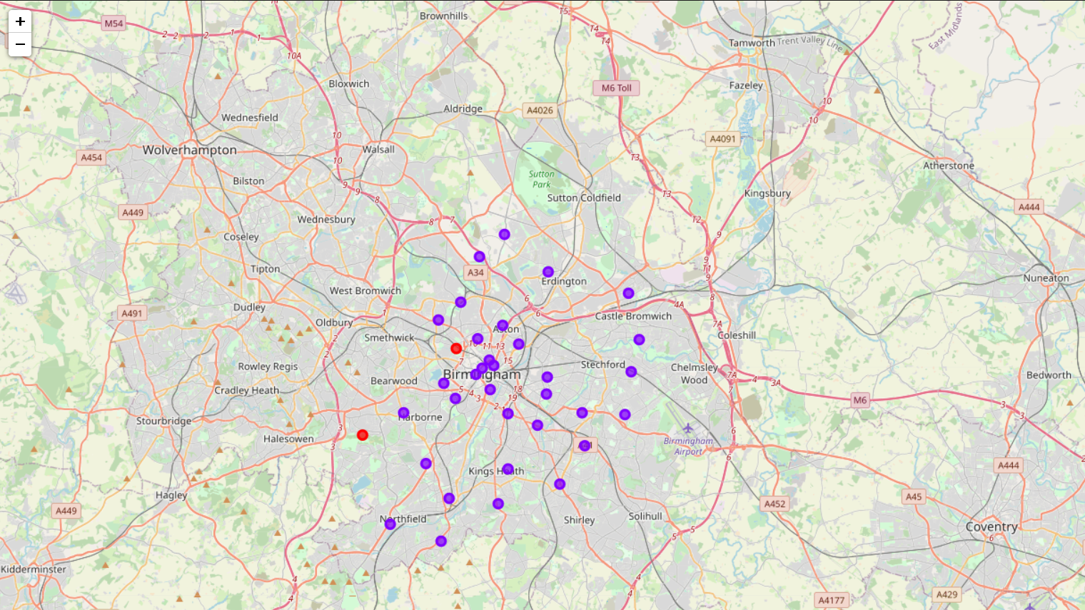

Figure 30- Map of Birmingham Cluster of venues' categories (map_clusters_Birmingham)

### 12.2.7 Analysing the different Clusters of Birmingham

### 12.2.7.1 Cluster 1 – Construction, Landscaping and Stadium

#### 12.2.7.1.1 Code 1- Getting Cluster 1 Data frame for Birmingham ( Birmingham_merged)

# Cluster 1

Birmingham_merged.loc[Birmingham_merged['Cluster Labels'] == 0, Birmingham_merged.columns[[1] + list(range(5, Birmingham_merged.shape[1]))]]

#### 12.2.7.1.2 Output 1- Cluster 1 Data frame for Birmingham venues’ categories ( Birmingham_merged_Cluster_1):

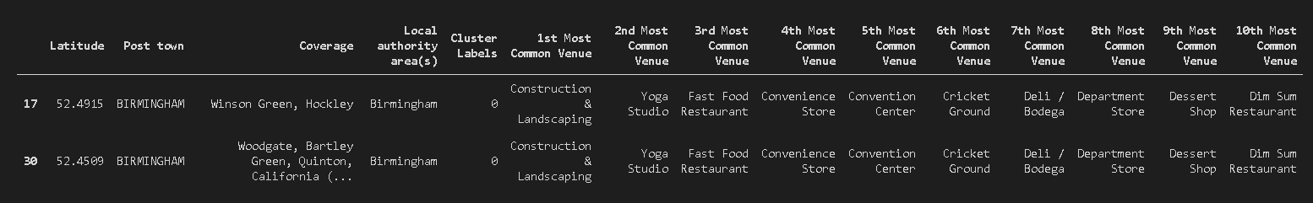

Figure 31- Cluster 1 from Data frame for Birmingham venues' categories ( Birmingham_merged_Cluster_1)

### 12.2.7.2 Cluster 2- Common Residential Necessities and Venues

#### 12.2.7.2.1 Code 1- Getting Cluster 2 Data frame from Birmingham data (Birmingham_merged)

# Cluster 2

Birmingham_merged.loc[Birmingham_merged['Cluster Labels'] == 1, Birmingham_merged.columns[[1] + list(range(5, Birmingham_merged.shape[1]))]]

#### 12.2.7.2.2 Output 1- Cluster 2 Data frame for Birmingham venues’ categories(Birmingham_merged_Cluster_2):

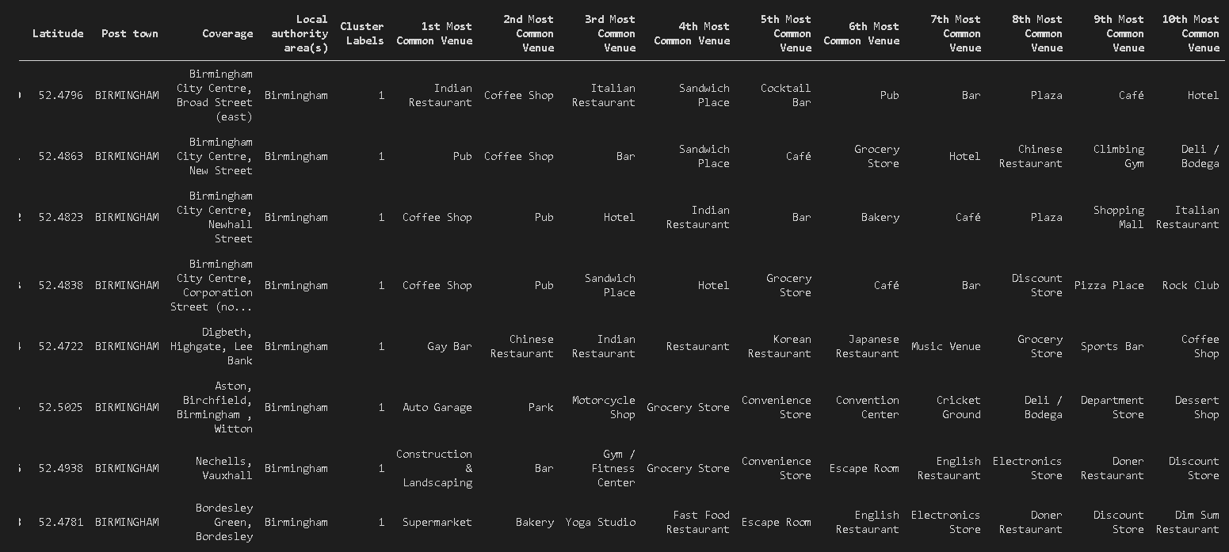

Figure 32- Cluster 2 Data frame for Birmingham venues' categories (Birmingham_merged_Cluster_2)

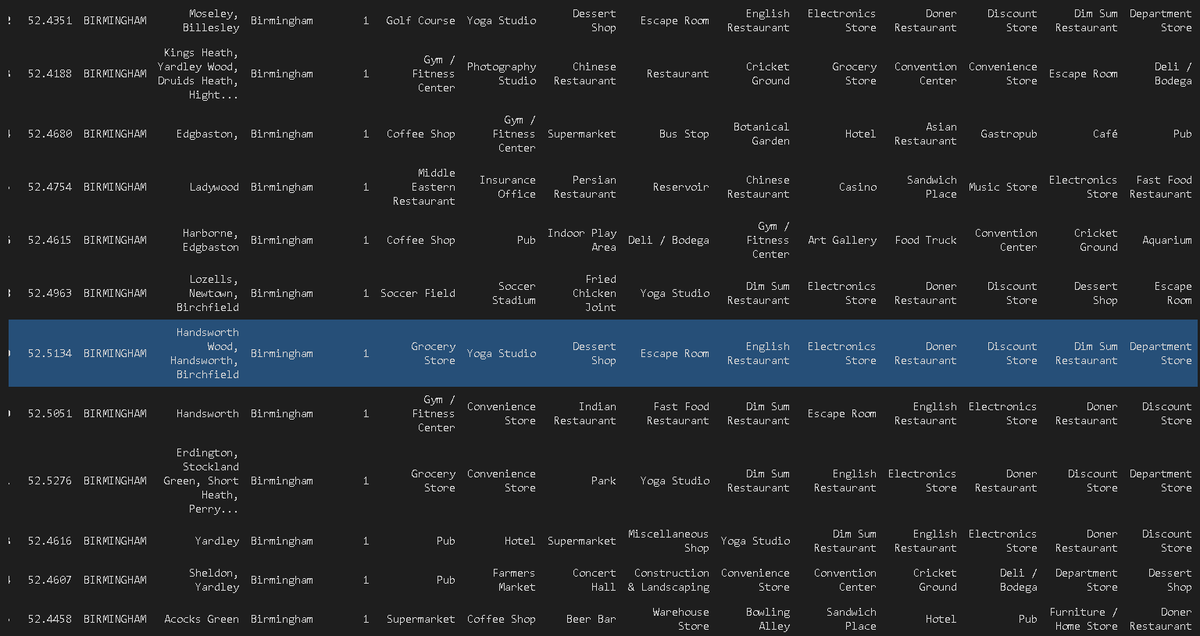

Figure 33-Cluster 2 Data frame for Birmingham venues' categories (Birmingham_merged_Cluster_2)

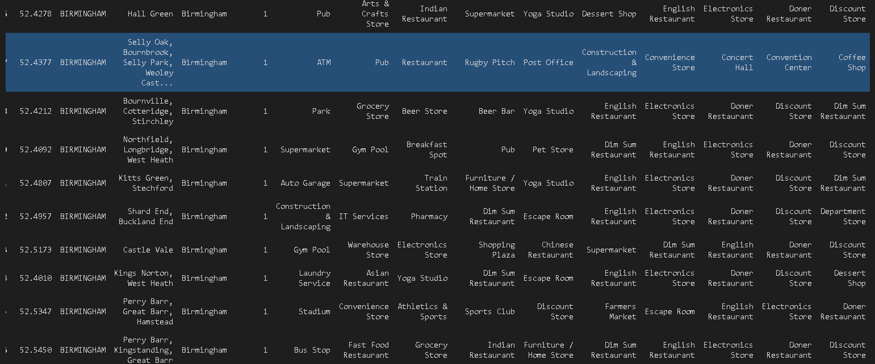

Figure 34-Cluster 2 Data frame for Birmingham venues' categories (Birmingham_merged_Cluster_2)

# 13.0 Results

## 13.1 East Central London Clusters

In East Central London 6 different clusters were formed with the method of K-means Clustering. They were labelled as following:

|  |  |
| --- | --- |
| **Cluster Number** | **Cluster Name** |
| 1 | Restaurant Venues- Variety of Foods |
| 2 | Hotels and Tourists Necessities |
| 3 | Common Residential Venues |
| 4 | Common Residential Venues |
| 5 | Fast food Venues |
| 6 | Tourist Attraction |

## 13.2 Birmingham Clusters

In Birmingham just 2 different clusters were formed with the method of K-means Clustering. They were labelled as following:

|  |  |
| --- | --- |
| **Cluster Number** | **Cluster Name** |
| 1 | Construction, Landscaping & Stadium |
| 2 | Common Residential Necessities & Venues |

# 14.0 Conclusion

# 15.0 Further Recommendation

# Appendix 1: Postcode Area Data Table Format

Table 6 Postcode Area District data of East Central London ( Office of National Statistics, 2012 )

|  |  |  |  |
| --- | --- | --- | --- |
| Postcode district | Post town | Coverage | Local authority area(s) |
| EC1A | LONDON | St Bartholomew's Hospital | City of London, Islington |
| EC1M | LONDON | Clerkenwell, Farringdon | Islington, Camden, City of London |
| EC1N | LONDON | Hatton Garden | Camden, City of London |
| EC1P | LONDON |  | non-geographic |
| EC1R | LONDON | Finsbury, Finsbury Estate (west) | Islington, Camden |
| EC1V | LONDON | Finsbury (east), Moorfields Eye Hospital | Islington, Hackney |
| EC1Y | LONDON | St Luke's, Bunhill Fields | Islington, City of London |
| EC2A | LONDON | Shoreditch | Islington, Hackney, City of London |
| EC2M | LONDON | Broadgate, Liverpool Street | City of London, Tower Hamlets |
| EC2N | LONDON | Old Broad Street, Tower 42 | City of London |
| EC2P | LONDON |  | non-geographic |
| EC2R | LONDON | Bank of England | City of London |
| EC2V | LONDON | Guildhall | City of London |
| EC2Y | LONDON | Barbican | City of London |
| EC3A | LONDON | St Mary Axe, Aldgate | City of London |
| EC3M | LONDON | Lloyd's of London, Fenchurch Street | City of London |
| EC3N | LONDON | Tower Hill, Tower of London | Tower Hamlets, City of London |
| EC3P | LONDON |  | non-geographic |
| EC3R | LONDON | Monument, Billingsgate | City of London |
| EC3V | LONDON | Cornhill, Gracechurch Street, Lombard Street | City of London |
| EC4A | LONDON | Fetter Lane | City of London, Westminster |
| EC4M | LONDON | St Paul's | City of London |
| EC4N | LONDON | Mansion House | City of London |
| EC4P | LONDON |  | non-geographic |
| EC4R | LONDON | Cannon Street | City of London |
| EC4V | LONDON | Blackfriars | City of London |
| EC4Y | LONDON | Temple | City of London, Westminster |
| EC50 | LONDON |  | non-geographic |

Table 7: Postcode district data (B) for Birmingham(Postcode Project,2012)

|  |  |  |  |
| --- | --- | --- | --- |
| Postcode district | Post town | Coverage | Local authority area(s) |
| B1 | BIRMINGHAM | Birmingham City Centre, Broad Street (east) | Birmingham |
| B2 | BIRMINGHAM | Birmingham City Centre, New Street | Birmingham |
| B3 | BIRMINGHAM | Birmingham City Centre, Newhall Street | Birmingham |
| B4 | BIRMINGHAM | Birmingham City Centre, Corporation Street (north) | Birmingham |
| B5 | BIRMINGHAM | Digbeth, Highgate, Lee Bank | Birmingham |
| B6 | BIRMINGHAM | Aston, Birchfield, Birmingham , Witton | Birmingham |
| B7 | BIRMINGHAM | Nechells, Vauxhall | Birmingham |
| B8 | BIRMINGHAM | Washwood Heath, Ward End, Saltley | Birmingham |
| B9 | BIRMINGHAM | Bordesley Green, Bordesley | Birmingham |
| B10 | BIRMINGHAM | Small Heath | Birmingham |
| B11 | BIRMINGHAM | Sparkhill, Sparkbrook, Tyseley | Birmingham |
| B12 | BIRMINGHAM | Balsall Heath, Sparkbrook, Highgate | Birmingham |
| B13 | BIRMINGHAM | Moseley, Billesley | Birmingham |
| B14 | BIRMINGHAM | Kings Heath, Yardley Wood, Druids Heath, Highter's Heath, Warstock | Birmingham |
| B15 | BIRMINGHAM | Edgbaston, | Birmingham |
| B16 | BIRMINGHAM | Ladywood | Birmingham |
| B17 | BIRMINGHAM | Harborne, Edgbaston | Birmingham |
| B18 | BIRMINGHAM | Winson Green, Hockley | Birmingham |
| B19 | BIRMINGHAM | Lozells, Newtown, Birchfield | Birmingham |
| B20 | BIRMINGHAM | Handsworth Wood, Handsworth, Birchfield | Birmingham |
| B21 | BIRMINGHAM | Handsworth | Birmingham |
| B23 | BIRMINGHAM | Erdington, Stockland Green, Short Heath, Perry Common | Birmingham |
| B24 | BIRMINGHAM | Erdington, Wylde Green, Tyburn | Birmingham |
| B25 | BIRMINGHAM | Yardley | Birmingham |
| B26 | BIRMINGHAM | Sheldon, Yardley | Birmingham |
| B27 | BIRMINGHAM | Acocks Green | Birmingham |
| B28 | BIRMINGHAM | Hall Green | Birmingham |
| B29 | BIRMINGHAM | Selly Oak, Bournbrook, Selly Park, Weoley Castle, California (part of) | Birmingham |
| B30 | BIRMINGHAM | Bournville, Cotteridge, Stirchley | Birmingham |
| B31 | BIRMINGHAM | Northfield, Longbridge, West Heath | Birmingham |
| B32 | BIRMINGHAM | Woodgate, Bartley Green, Quinton, California (part of) | Birmingham |
| B33 | BIRMINGHAM | Kitts Green, Stechford | Birmingham |
| B34 | BIRMINGHAM | Shard End, Buckland End | Birmingham |
| B35 | BIRMINGHAM | Castle Vale | Birmingham |
| B36 | BIRMINGHAM | Castle Bromwich, Smith's Wood, Bromford, Hodge Hill | Birmingham, Solihull |
| B37 | BIRMINGHAM | Chelmsley Wood, Marston Green, Kingshurst, Fordbridge | Solihull |
| B38 | BIRMINGHAM | Kings Norton, West Heath | Birmingham |
| B40 | BIRMINGHAM | National Exhibition Centre, Birmingham International Airport, Marston Green, Bickenhill | Solihull |
| B42 | BIRMINGHAM | Perry Barr, Great Barr, Hamstead | Birmingham |
| B43 | BIRMINGHAM | Great Barr, Hamstead | Birmingham, Sandwell, Walsall |
| B44 | BIRMINGHAM | Perry Barr, Kingstanding, Great Barr | Birmingham |
| B45 | BIRMINGHAM | Rednal, New Frankley, Rubery, Cofton Hackett, Barnt Green, Lickey, Longbridge, Northfield (part) | Birmingham, Bromsgrove |
| B46 | BIRMINGHAM | Water Orton, Coleshill, Nether Whitacre | North Warwickshire |
| B47 | BIRMINGHAM | Hollywood, Wythall | Bromsgrove |
| B48 | BIRMINGHAM | Alvechurch | Bromsgrove |
| B49 | ALCESTER | Alcester | Stratford-on-Avon |
| B50 | ALCESTER | Bidford-on-Avon | Stratford-on-Avon |
| B60 | BROMSGROVE | Bromsgrove (east) | Bromsgrove |
| B61 | BROMSGROVE | Bromsgrove (west) | Bromsgrove |
| B62 | HALESOWEN | Halesowen (east), Romsley, Hunnington, Quinton (part) | Dudley, Bromsgrove, Birmingham |
| B63 | HALESOWEN | Halesowen (west and town centre), Hayley Green, Hasbury | Dudley, Bromsgrove |
| B64 | CRADLEY HEATH | Cradley Heath, Old Hill | Sandwell |
| B65 | ROWLEY REGIS | Rowley Regis, Blackheath | Birmingham, Sandwell |
| B66 | SMETHWICK | Smethwick (east and north), Bearwood (east) | Sandwell |
| B67 | SMETHWICK | Smethwick (west), Bearwood (west), Londonderry | Sandwell |
| B68 | OLDBURY | Langley, Brandhall, Quinton (part of) | Sandwell |
| B69 | OLDBURY | Oldbury, Tividale | Sandwell |
| B70 | WEST BROMWICH | West Bromwich (south, west and town centre) | Sandwell |
| B71 | WEST BROMWICH | West Bromwich (north) | Sandwell |
| B72 | SUTTON COLDFIELD | Sutton Coldfield town centre, Maney, Wylde Green, Erdington | Birmingham |
| B73 | SUTTON COLDFIELD | Boldmere, New Oscott, Wylde Green | Birmingham |
| B74 | SUTTON COLDFIELD | Four Oaks, Mere Green, Little Aston, Streetly | Birmingham, Lichfield, Walsall |
| B75 | SUTTON COLDFIELD | Sutton Trinity, Falcon Lodge, Rectory | Birmingham |
| B76 | SUTTON COLDFIELD | Walmley, Minworth | Birmingham |
| B77 | TAMWORTH | Tamworth, Wilnecote, Amington | Tamworth, North Warwickshire |
| B78 | TAMWORTH | Tamworth, Fazeley, Kingsbury, Polesworth | Tamworth, North Warwickshire |
| B79 | TAMWORTH | Tamworth, Warton | Tamworth, North Warwickshire |
| B80 | STUDLEY | Studley | Stratford-on-Avon |
| B90 | SOLIHULL | Shirley, Solihull Lodge, Majors Green, Dickens Heath, Cheswick Green | Solihull, Bromsgrove |
| B91 | SOLIHULL | Solihull | Solihull |
| B92 | SOLIHULL | Olton, Elmdon, Bickenhill, Hampton-in-Arden | Solihull |
| B93 | SOLIHULL | Knowle, Dorridge, Bentley Heath, Tilehouse Green | Solihull |
| B94 | SOLIHULL | Hockley Heath, Earlswood | Solihull |
| B95 | HENLEY-IN-ARDEN | Henley-in-Arden | Stratford-on-Avon |
| B96 | REDDITCH | Feckenham | Redditch |
| B97 | REDDITCH | Redditch (west), Callow Hill, Webheath | Redditch |
| B98 | REDDITCH | Redditch (east), Beoley | Redditch |
| B99 | BIRMINGHAM | | non-geographic |

# Appendix B: Ethnic Group Distributions

Table 8- Ethnic group population, London 2001 & 2011. ( Census, 2011)

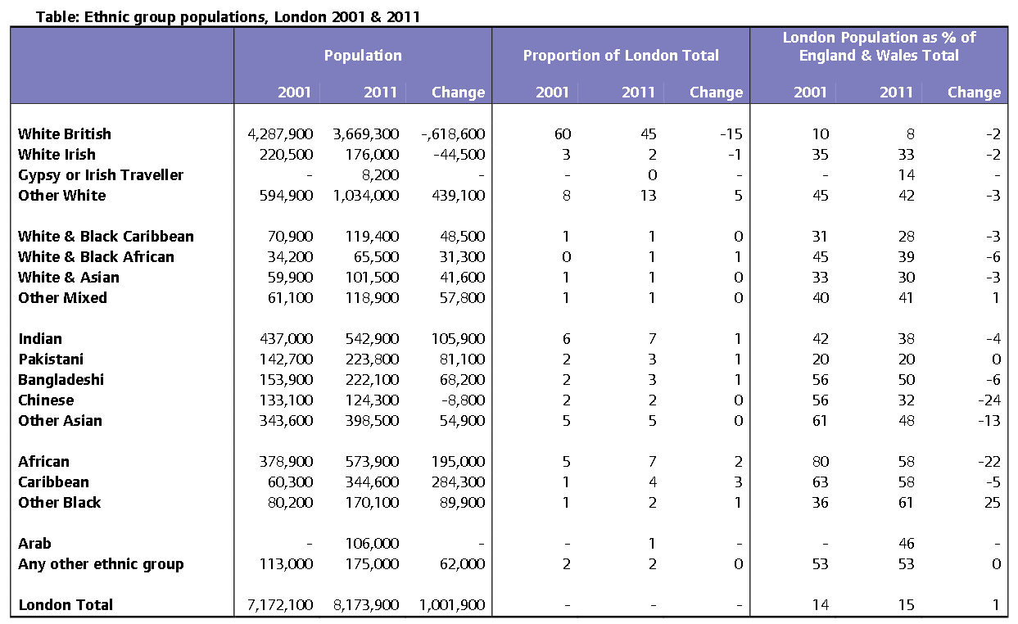

Table 9 Racial make- up of London boroughs 2011 ( Census, 2011)

| Racial make-up of London boroughs (2011) | | | | | |
| --- | --- | --- | --- | --- | --- |
| **Local authority** | **White** | **Mixed** | **Asian** | **Black** | **Other** |
| **Barnet** | 64.1 | 4.8 | 18.5 | 7.7 | 4.8 |
| **Barking and Dagenham** | 58.3 | 4.2 | 15.9 | 20 | 1.6 |
| **Bexley** | 81.9 | 2.3 | 6.6 | 8.5 | 0.8 |
| **Brent** | 36.3 | 5.1 | 34.1 | 18.8 | 5.8 |
| **Bromley** | 84.3 | 3.5 | 5.2 | 6 | 0.9 |
| **Camden** | 66.3 | 5.6 | 16.1 | 8.2 | 3.8 |
| **City of London** | 78.6 | 3.9 | 12.7 | 2.6 | 2.1 |
| **Croydon** | 55.1 | 6.6 | 16.4 | 20.2 | 1.8 |
| **Ealing** | 49 | 4.5 | 29.7 | 10.9 | 6 |
| **Enfield** | 61 | 5.5 | 11.2 | 17.2 | 5.1 |
| **Greenwich** | 62.5 | 4.8 | 11.7 | 19.1 | 1.9 |
| **Hackney** | 54.7 | 6.4 | 10.5 | 23.1 | 5.3 |
| **Haringey** | 60.5 | 6.5 | 9.5 | 18.8 | 4.7 |
| **Harrow** | 42.2 | 4 | 42.6 | 8.2 | 2.9 |
| **Havering** | 87.7 | 2.1 | 4.9 | 4.8 | 0.6 |
| **Hammersmith and Fulham** | 68.1 | 5.5 | 9.1 | 11.8 | 5.5 |
| **Hillingdon** | 60.6 | 3.8 | 25.3 | 7.3 | 3 |
| **Hounslow** | 51.4 | 4.1 | 34.4 | 6.6 | 3.6 |
| **Islington** | 68.2 | 6.5 | 9.2 | 12.8 | 3.4 |
| **Kensington and Chelsea** | 70.6 | 5.7 | 10 | 6.5 | 7.2 |
| **Kingston upon Thames** | 74.5 | 3.9 | 16.3 | 2.5 | 2.7 |
| **Lambeth** | 57.1 | 7.6 | 6.9 | 25.9 | 2.4 |
| **Lewisham** | 53.5 | 7.4 | 9.3 | 27.2 | 2.6 |
| **Merton** | 64.9 | 4.7 | 18.1 | 10.4 | 1.9 |
| **Newham** | 29 | 4.5 | 43.5 | 19.6 | 3.5 |
| **Redbridge** | 42.5 | 4.1 | 41.8 | 8.9 | 2.7 |
| **Richmond upon Thames** | 86 | 3.6 | 7.3 | 1.5 | 1.6 |
| **Southwark** | 54.3 | 6.2 | 9.4 | 26.9 | 3.3 |
| **Sutton** | 78.6 | 3.8 | 11.6 | 4.8 | 1.3 |
| **Tower Hamlets** | 45.2 | 4.1 | 41.1 | 7.3 | 2.3 |
| **Waltham Forest** | 52.2 | 5.3 | 21.1 | 17.3 | 4.1 |
| **Wandsworth** | 71.4 | 5 | 10.9 | 10.7 | 2.1 |
| **Westminster** | 61.7 | 5.2 | 14.5 | 7.5 | 11.1 |

Table 10- Ethnic Group Distribution Birmingham ( Census, 2011)

|  |  |
| --- | --- |
| Birmingham Ethnic Group Distribution | |
| All categories: Ethnic group | 1,073,045 |
| White | 621,636 |
| English/Welsh/Scottish/Northern Irish/British | 570,217 |
| Irish | 22,021 |
| Gypsy or Irish Traveller | 408 |
| Other White | 28,990 |
| Mixed/multiple ethnic group | 47,605 |
| White and Black Caribbean | 24,720 |
| White and Black African | 3,223 |
| White and Asian | 11,186 |
| Other Mixed | 8,476 |
| Asian/Asian British | 285,640 |
| Indian | 64,621 |
| Pakistani | 144,627 |
| Bangladeshi | 32,532 |
| Chinese | 12,712 |
| Other Asian | 31,148 |
| Black/African/Caribbean/Black British | 96,360 |
| African | 29,991 |
| Caribbean | 47,641 |
| Other Black | 18,728 |
| Other ethnic group | 21,804 |
| Arab | 10,910 |
| Any other ethnic group | 10,894 |